SUBCOURSE EDITION
IT0642 A

US ARMY INTELLIGENCE CENTER

PERFORM RAILWAY ANALYSIS

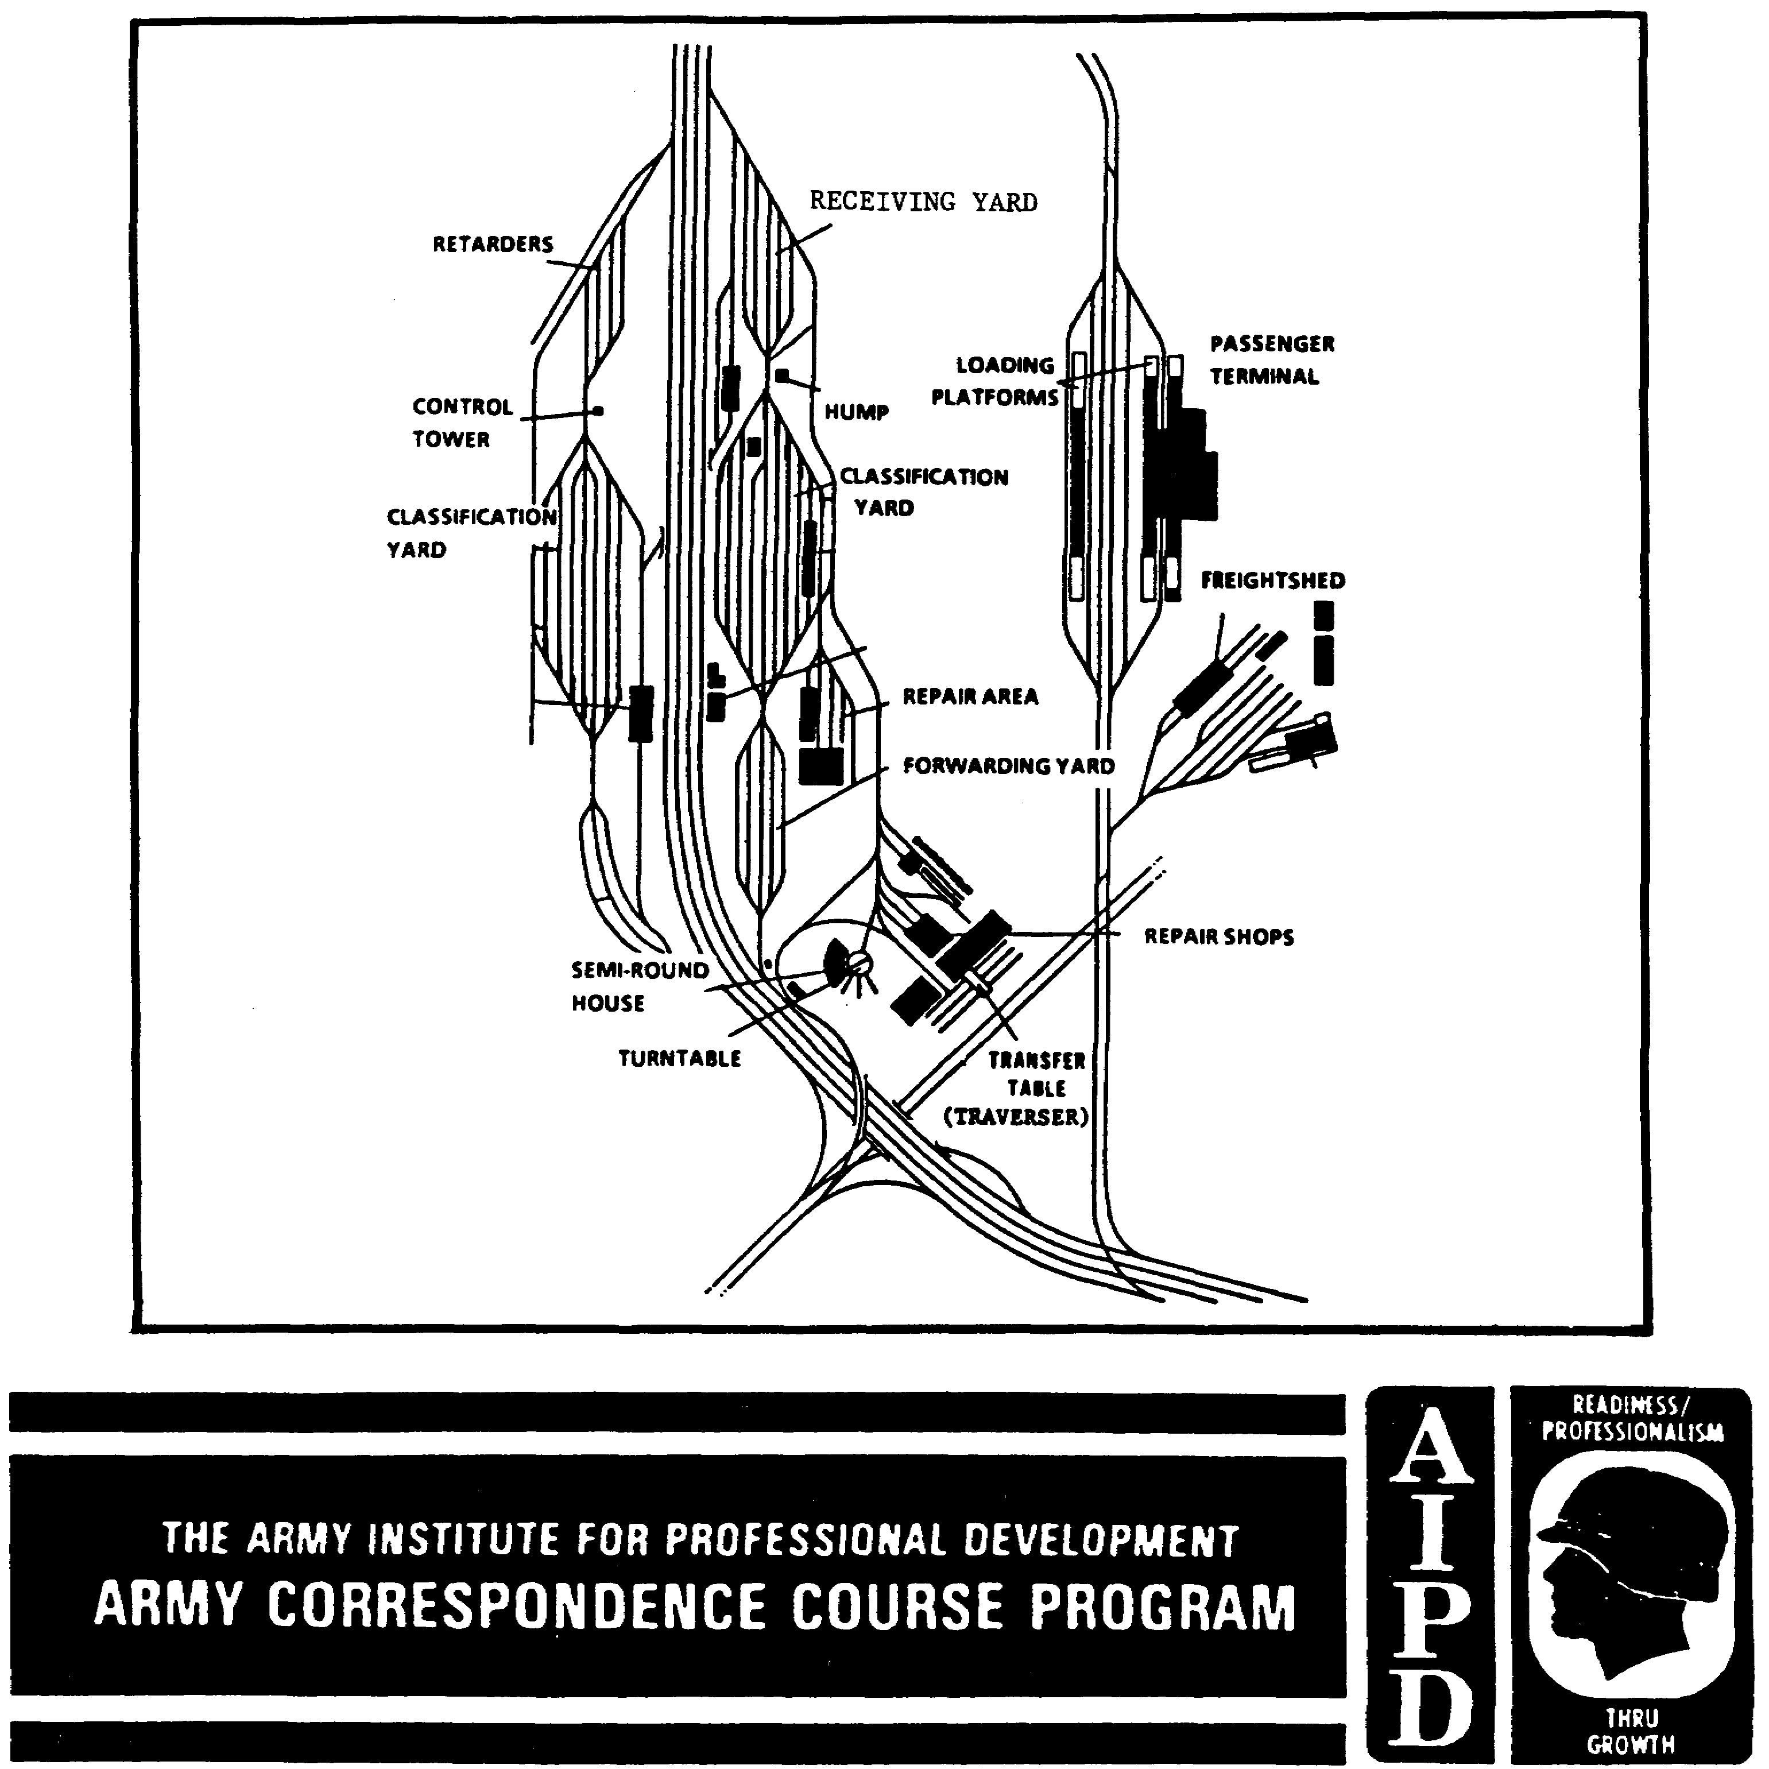

PERFORM RAILWAY ANALYSIS

Subcourse Number IT0642

EDITION A

US Army Intelligence Center
Fort Huachuca, AZ 85613-7000

3 Credit Hours

SUBCOURSE OVERVIEW

This subcourse is designed to teach you basic procedures involved in performing a railway analysis. Contained within this subcourse is instruction on how to analyze railways.

There are no prerequisites for this subcourse.

This subcourse reflects the doctrine which was current at the time this subcourse was prepared.

TERMINAL LEARNING OBJECTIVE

TASK: You will analyze railway systems.

CONDITIONS: You will have access to extracts from FM 30-10, STP 34-96D1-SM, Jane's World Railways, and Jane's Urban Transport Systems.

STANDARDS: You will analyze railways in accordance with FM 30-10, STP 34-96D1-SM, Jane's World Railways, and Jane's Urban Transport Systems.

ACKNOWLEDGEMENT: Special thanks go to Jane's Information Group for permitting us to use selected information and line drawings from their Jane's World Railways, 1989-90, and Jane's Urban Transport Systems, 1988.

i IT0642

TABLE OF CONTENTS

Section Page

Subcourse Overview i

Lesson: Perform Railway Analysis 1

Part A: Railway Factors and Terminology 2
Part 8: Railyards and Terminals 6
Part C: Support Facilities 11
Part D: Service and Repair Facilities 14
Part E: Rail Systems 18
Part F: Rolling Stock and Track Driving Vehicles 21
Part G: Railroad Vulnerabilities 31
Practice Exercise 33
Answer Key and Feedback 36

Appendix A: Worldwide Railroad Gauges 43

Appendix B: Glossary 47

IT0642 iii
LESSON

PERFORM RAILWAY ANALYSIS

MOS Manual Tasks: 301-338-1843
301-338-3701

OVERVIEWS

TASK DESCRIPTION:

In this lesson you will learn to analyze railways.

LEARNING OBJECTIVE:

ACTIONS: Analyze railway systems.

CONDITIONS: You will be given access to extracts from FM 30-10, STP 34-96D1-SM, Jane's World Railways, and Jane's Urban Transport Systems.

STANDARDS: Analysis of railways systems will be in accordance with FM 30-10, STP 34-96D1-SM, Jane's World Railways, and Jane's Urban Transport Systems.

REFERENCES: The material contained in this lesson was derived from the following publications:

FM 30-10
STP 34-96D1-SM
Jane's World Railways, 1989-90
Jane's Urban Transport Systems, 1988.

INTRODUCTION

Railroads are a very important type of inland transportation in most countries of the world. Their importance is based on their capability to handle freight and passengers. From a military standpoint, the importance of railroads results not only from their contribution to the overall economic welfare of a country, but also to the direct logistic support afforded military operations through the movement of troops and equipment.

1 IT0642

PART A: RAILWAY FACTORS AND TERMINOLOGY

1. Railways In general. It is necessary to consider those facilities that are required for carrying out the railroad's basic mission, the movement of passengers and freight. Railway facilities can conveniently be divided into three basic groups (Figure 1-1):

* Routes.
* Yards and terminals.
* Rolling stock.

a. Routes are the facilities of a railroad over which passengers and freight are moved between places. Route components include the roadbed, rails and ties, bridges, tunnels, signaling devices, and control equipment. The complexity of routes may vary from the multitrack installations commonly used between large, closely spaced cities to the hastily improvised single-track line used for forward military operations.

b. Rail yards and terminals represent the fixed points in the network of railroad facilities at which passengers and freight are loaded and unloaded.

(1) The activities at yards and terminals can be classified as passenger and freight handling, vehicle handling, and vehicle service and repair.

(2) Passenger handling includes accommodating incoming and departing passengers, loading and unloading mail and baggage, and servicing and repairing passenger vehicles.

(3) Freight handling includes loading, unloading, storing, transloading, and transhipping commodities of all types.

(4) Vehicle handling includes the making up and disassembling of trains and special operations such as rail ferrying.

(5) Service and repair activities include the servicing, repairing, and maintenance of freight cars and locomotives.

NOTE: It should be apparent that although the handling of passengers and freight is of primary importance in rail yards and terminals, such activities as service and repair are necessary to support the primary operation.

c. Rolling stock forms the third group of railroad facilities. It can be classified according to use as:

* Passenger.
* Freight.
* Military or special purpose.

IT0642 2

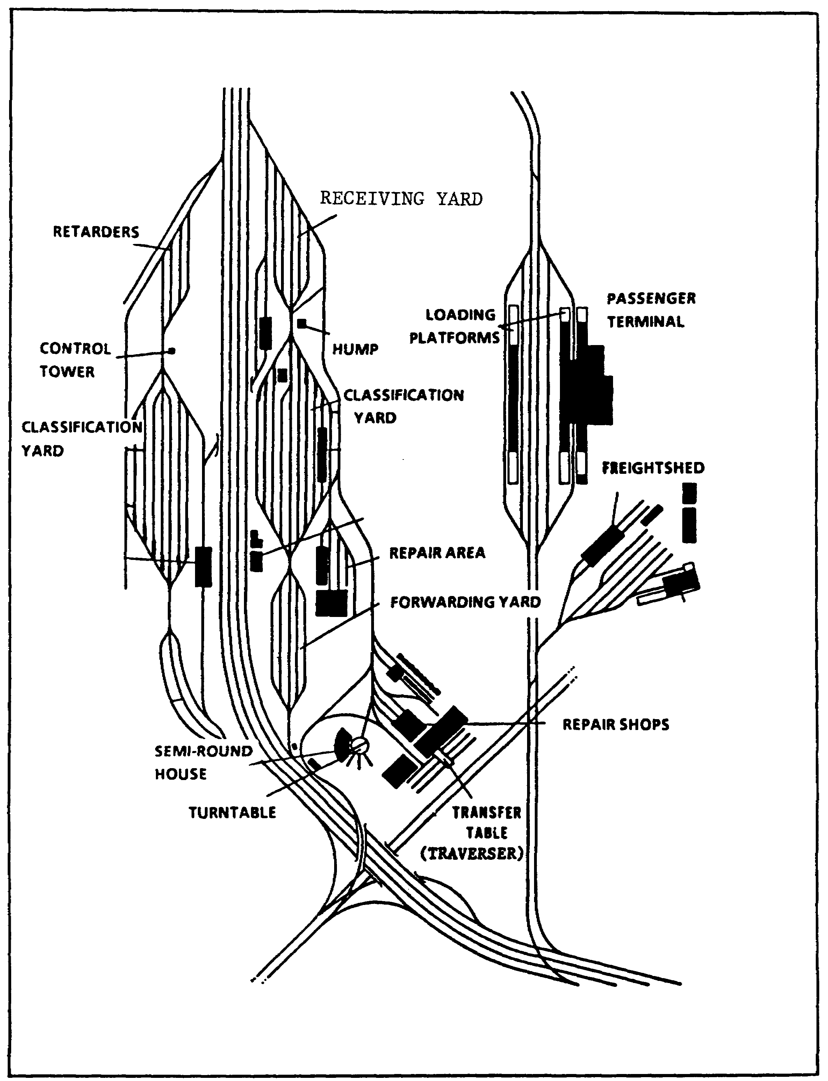

Figure 1-1. Standard Railway Facilities.

3 IT 0642
(1) Passenger and freight vehicles are used to perform the basic mission of the railroad.

(2) Military vehicles can be passenger or freight vehicles that have been adapted for military use, or can be specially designed to handle a specific type of military materiel, such as a railroad gun.

(3) Special purpose vehicles include snowplows, railroad cranes, tracklayers, and right-of-way weeders.

2. Engineering design and railway routes. Because engineering design and construction principles are universal, railroad facilities throughout the world look much alike. There are, however, regional variations which the imagery analyst (IA) should be familiar with. Routes and vehicles in particular may vary from one geographic region to another. Railroad routes have definite characteristics which enable the IA to distinguish them from roads and highways on aerial imagery. Some of these are:

a. Long smooth curves -there are no angular bends on railroad routes.

b. Cuts and fills -to keep the track as level as possible because of the difficulty trains have in negotiating excessive grades.

c. Railroad routes follow a contour line course to avoid excessive gradient -railroads seldom have more than 3 or 4 percent gradient.

d. There will be very few houses or other buildings along the right of way of a rail line except possibly within the city limits of larger cities.

e. All railroad junctions or rail branches appear to come to a point on aerial imagery. This is a very distinctive feature of railroad routes, which is extremely useful in distinguishing them from other forms of transportation or communication routes.

f. Crossings, such as roads or highways, rivers and canals, may pass over or under a railroad route to allow uninterrupted traffic movements on both routes. Where roads cross railroad tracks at grades, images of individual tracks are often discernible at the crossings where the tone of the railroad route is changed.

g. Where terrain permits, railroads follow as straight a line as possible. Rolling terrain leads to the blasting of cuts, the construction of fills, and the drilling of tunnels to maintain a fairly level route.

h. Railroad bridges are usually much narrower than the approaches, which are frequently located on a fill or in a cut. The absence of continuous flooring or many railroad bridges makes them appear much narrower than they actually are.

IT0642 4

3. The gauge and right-of-way.

a. The gauge of a railroad is the distance between the inner sides of the rails on a running track. This distance varies in different parts of the world and may vary within a given country.

(1) Throughout Canada, the United States, and in most of Europe, the standard gauge measures 4 feet 8-1/2 inches (in)(4.71ft).

(2) A gauge of 5ft or wider is found in the USSR, Iceland, Finland, and Spain, but narrower gauges of 3ft 6in and 3ft 3-3/8in are found frequently in Africa.

(3) The use of narrow gauges is somewhat limited to, and usually found in mountainous areas, industrial areas, mines, logging areas, supply dumps, and coastal defense areas.

(4) Many of the countries that used different gauges in the past are now adopting the standard gauge of 4ft 8-1/2in (4.71ft) because of their imports of US-made rolling stock.

NOTE: A knowledge of railroad gauges is especially useful to the IA because widths can provide a known ground distance and thus determine photo scale when other methods have failed (Appendix A). In addition, by knowing the railroad gauges of different countries and that a change of gauges may occur at international borders, the IA will know where to look for transshipment points and warehouses where the goods are held while awaiting transfer from rolling stock of one width to a railroad of another gauge.

b. The railway right-of-way comprises the rails, ties, ballast, and prepared bed upon which they lie (Figure 1-2). The shade characteristics of the right of way on aerial photos generally appears to be medium to dark, caused by ashes, coal, or oil that has been deposited by the engines.

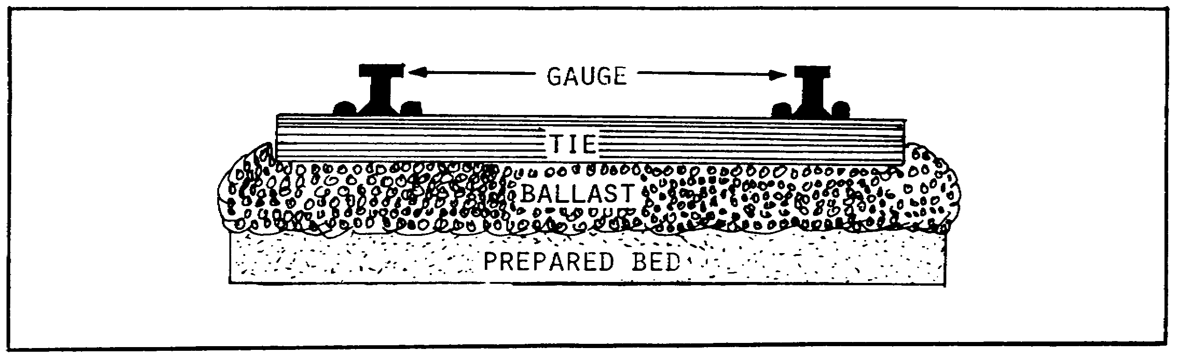

Figure 1-2. Right-of-way.

5 IT0642

PART B: RAILYARDS AND TERMINALS

1. Receiving yards. Receiving yards accommodate incoming trains and either hold the train within the yard or pass it on to the classification yard (Figures 1-3 and 1-4). Receiving yard track length should hold a standard train of maximum anticipated length. This should include space for locomotive and caboose plus 200 feet (ft) stopping distance. A choke point is usually between the receiving and classification yards.

NOTE: To identify a receiving yard, you should compare it against the classification yard (Figure 1-4). Furthermore, the yard that does not have a switch engine is the receiving yard.

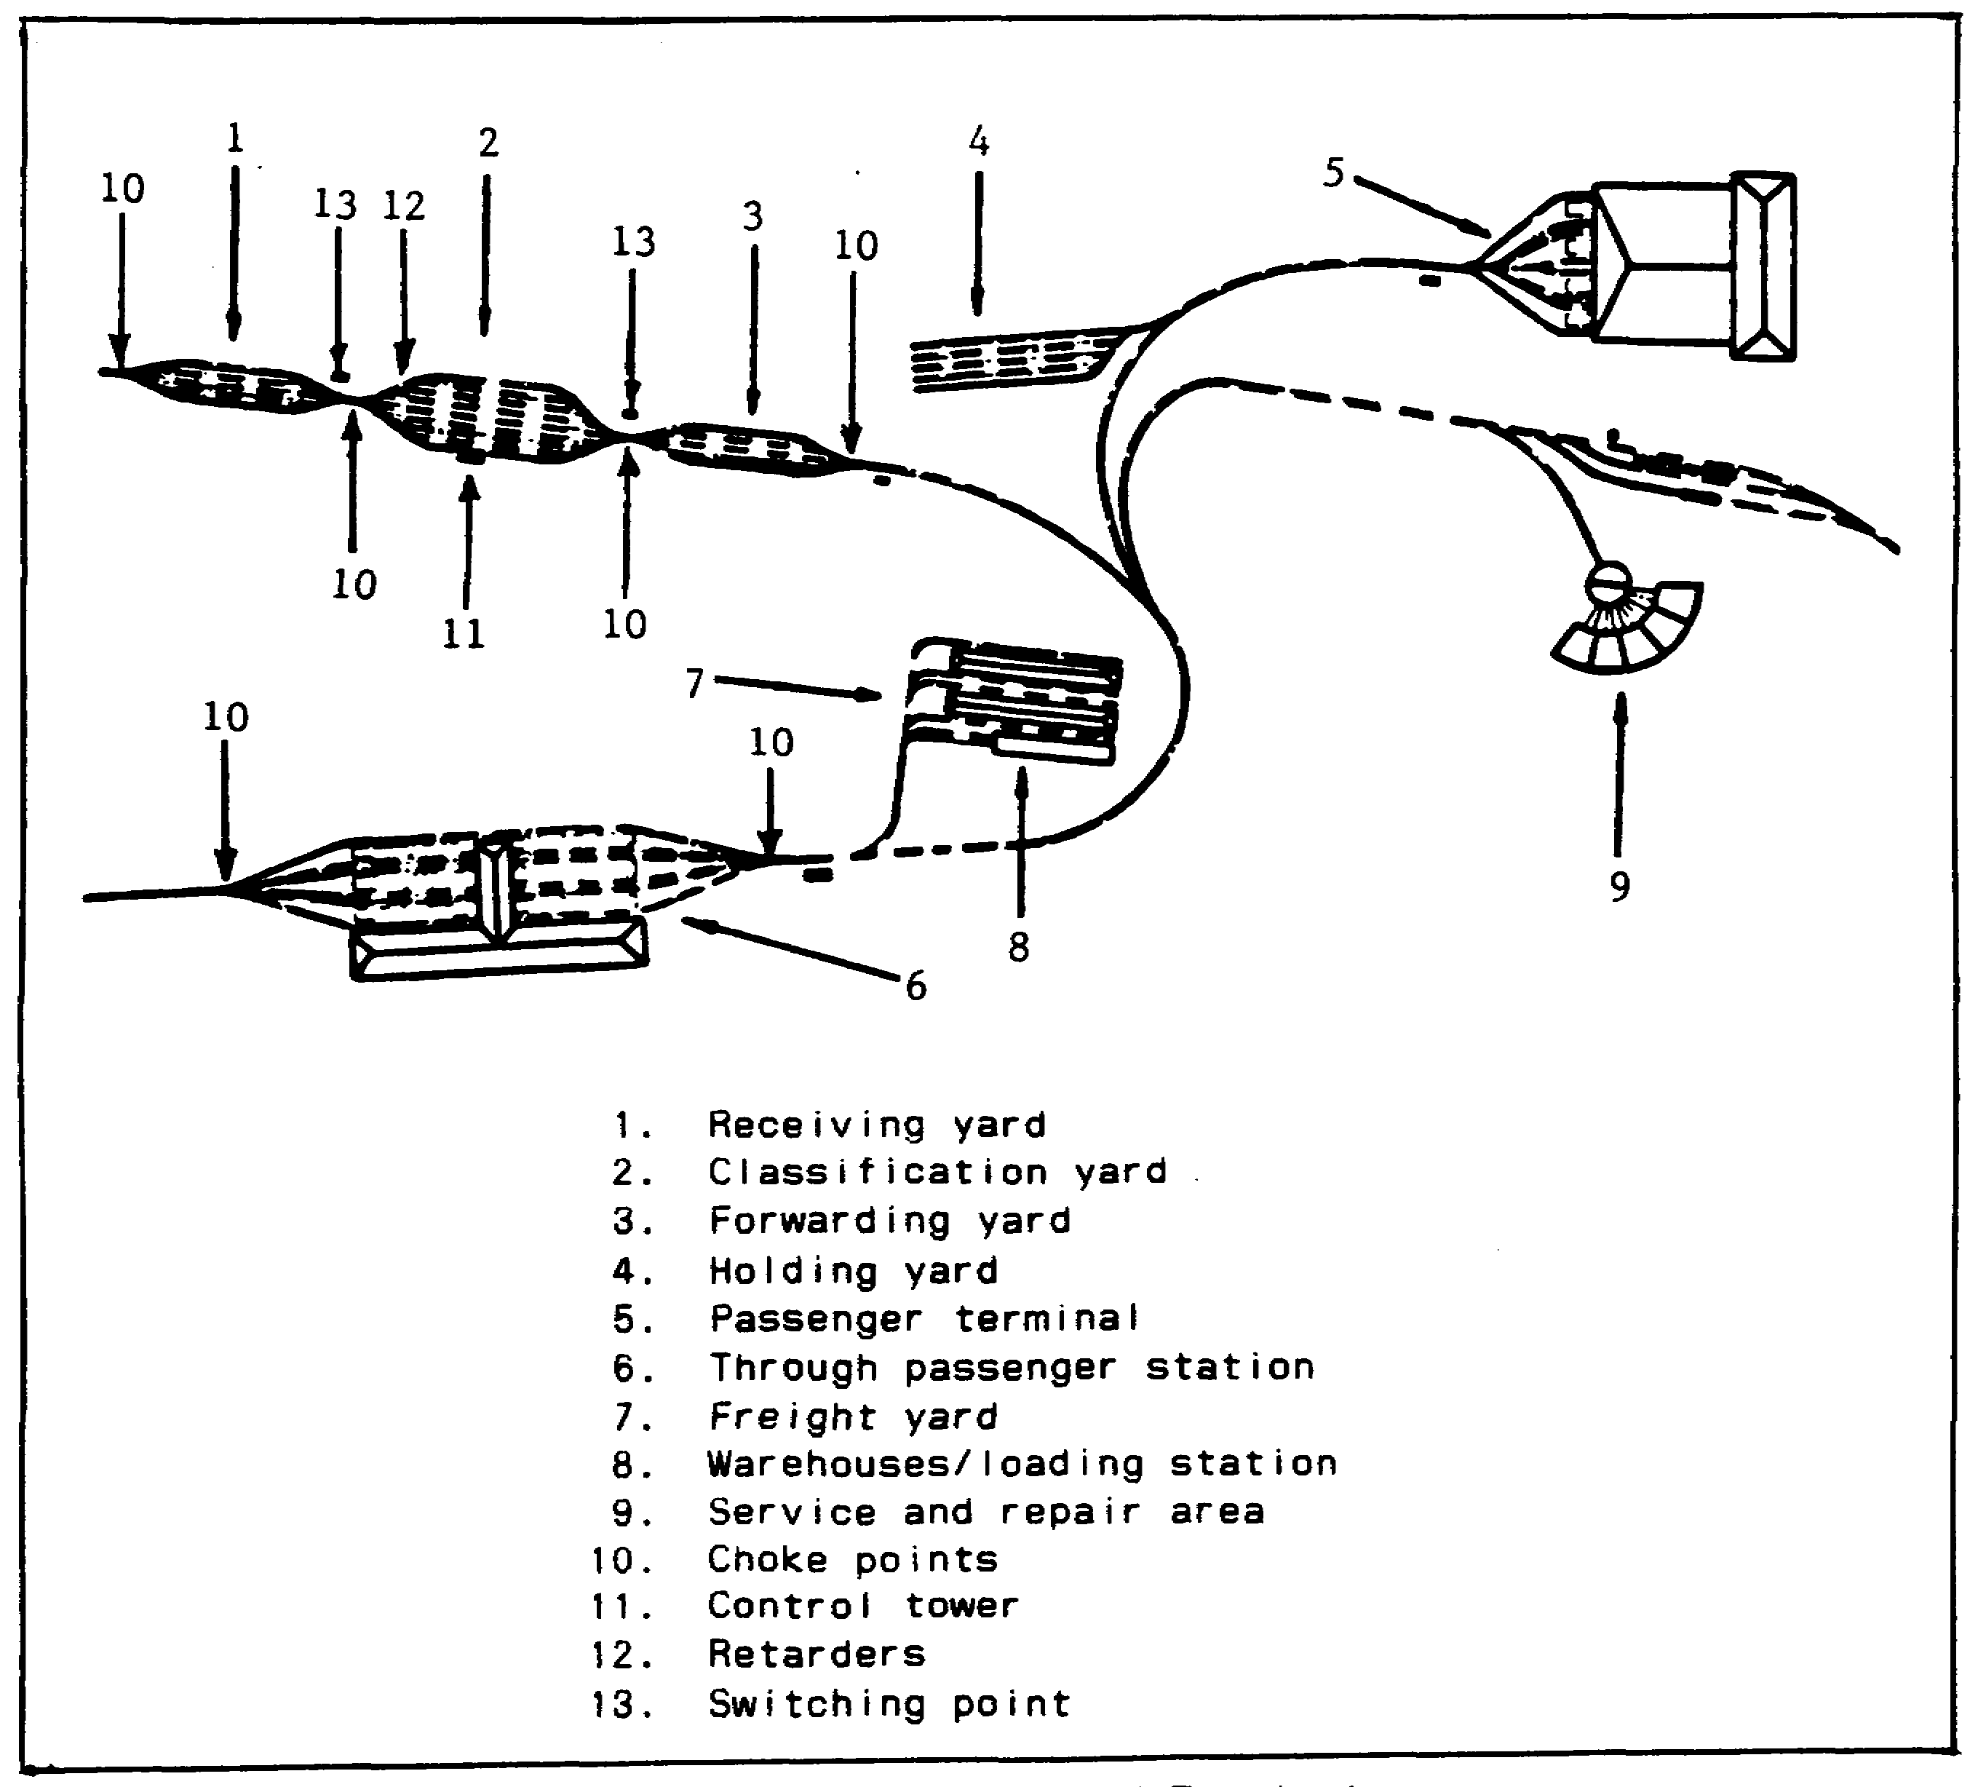

Figure 1-3. Railyards and Terminals.

IT0642 6

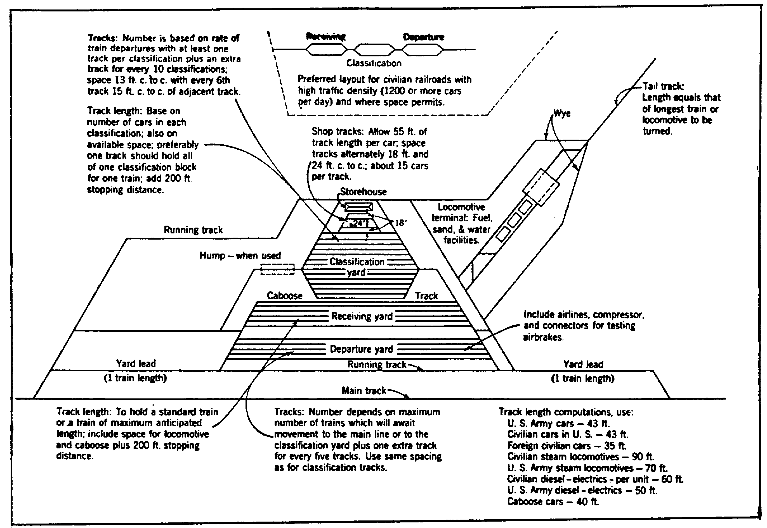

Figure 1-4. General Layout of a Major Marshaling Yard.

2. Classification yards. Classification yards are where trains are broken down and reformed into other trains. After the cars have been broken down, they are moved into the forwarding yard to await departure (Figure 1-4).

a. Classification yards can be identified by a large group of parallel tracks with a restricted (one or two track) entrance and exit called a choke point. In an active classification yard, numerous freight cars and small switch engines will be found.

b. Frequently, two or more classification yards are found next to each other, with their entrances through a choke point. If this choke point is higher than either classification yard, it is known as a hump.

c. Cars to be sorted are pushed from one yard, over the summit of the hump, and coasted into a previously selected track of the other yard. The cars speed while coasting to the next yard is controlled by a series of brakes known as retarders which are attached to the tracks to slow the cars down after leaving the hump.

d. Car sorting is also done by having one yard slightly higher than the next one, allowing cars to coast out of one yard, through the choke point, into a previously selected track of the other yard.

7 IT0642

e. A third method of sorting is that of pushing each individual car into place by using a switch engine.

f. Number of tracks is based on rate of train departures with at least one track per classification plus an extra track for every 10 classifications. Tracks are spaced 13ft center to center (c to c) with every sixth track c to c of adjacent track.

g,. Track length is based on number of tracks in each classification and on available space. Preferably one track should hold all of one classification block for one train. Add 200ft stopping distance.

3. Forwarding or departure yard.

a. The forwarding yard is where a newly madeup train is sent after leaving the classification yard. The train is either held for departure or sent right out to another part of the country. Number of tracks depends on maximum number of trains which will await movement to the main line or to the classification yard plus one extra track for every five tracks (Figure 1-4).

b. A forwarding yard is similar in size to the receiving yard; numerous freight cars, one or more switch engines, and a road locomotive can be found. At the entrance of the forwarding yard is normally a choke point.

REMEMBER: The forwarding yard is the opposite end of the receiving yard. If nongravity exists, look at the two smaller yards adjacent to the classification yard--one is receiving, the other forwarding.

4. Marshaling yards. Marshaling yard is the term for the combined receiving, classification, and forwarding or departure yard. The first yard is the receiving yard, followed by the largest of the three yards, the classification yard. The forwarding yard is the last yard. You can determine the traffic flow as follows:

a. Non-gravity or flat marshaling yard. Trains entering the receiving yard release the rolling stock. The rolling stock is then transferred to the classification yard. A switch engine is used to classify the rolling stock by track and destination before it is pushed into the forwarding yard (Figure 1-). No retarders are found in classification and forwarding yards of a non-gravity system. Normally, switch engines are located in the smaller of the two yards, which is the forwarding yard, and thus the traffic flow can be determined (Figure 1-6).

IT0642 8

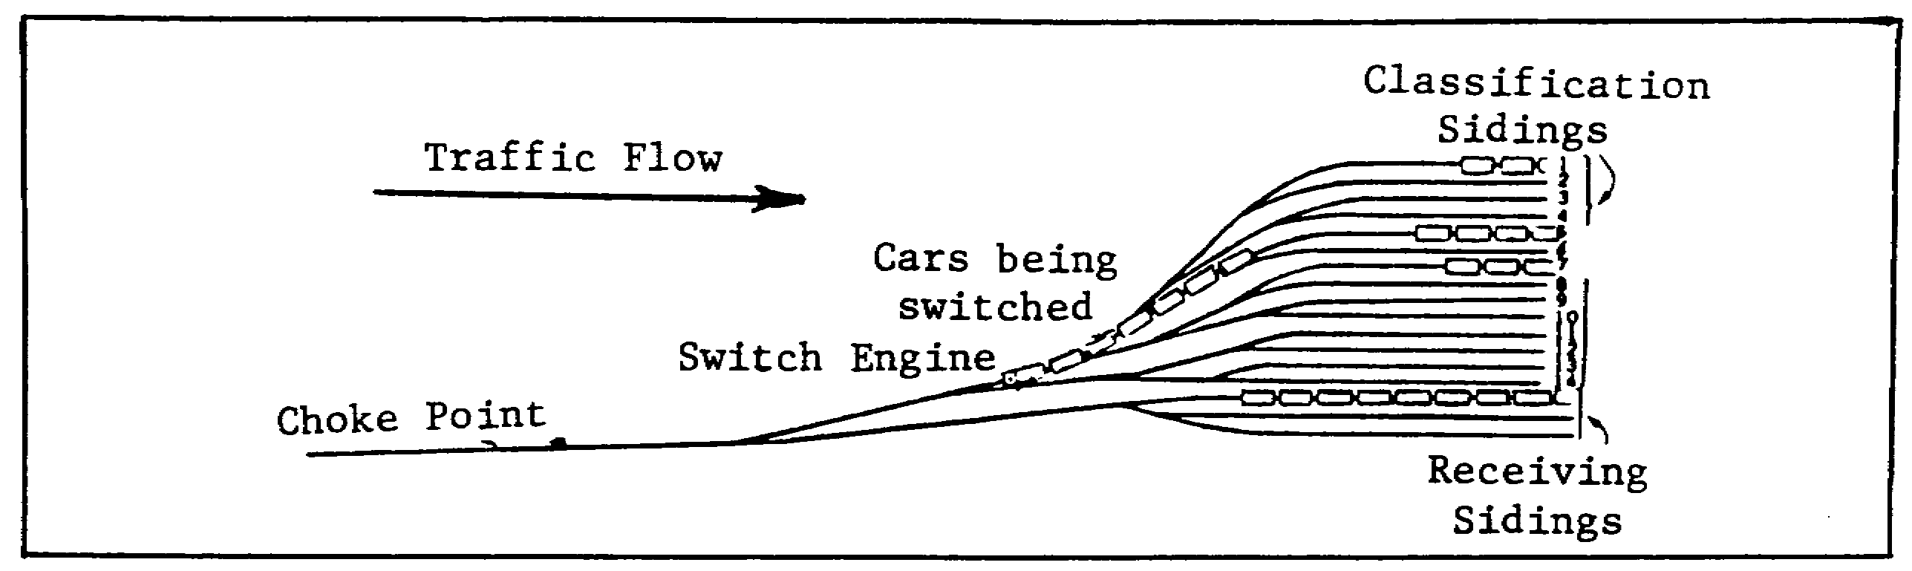

Figure 1-5. Traffic Flow Non-Gravity Marshaling Yard.

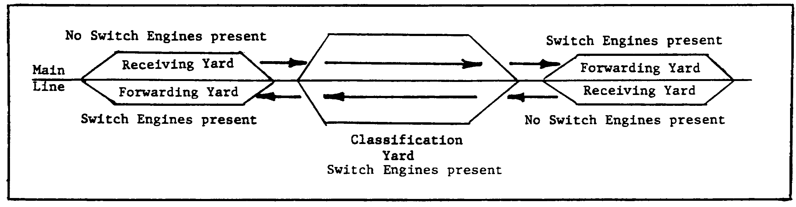

Figure 1-6. Traffic Flow Non-Gravity Marshaling Yard.

b. Retarders are long metal bars that slow down rolling stock entering the classification yard. The retarders are always closest to the receiving yard in a marshaling yard configuration (Figure 1-7). The traffic flow can be determined by the location of the retarders in the classification yard near the choke point adjacent to the receiving yard. Furthermore, a switch engine is in the receiving yard pushing cars to the hump summit.

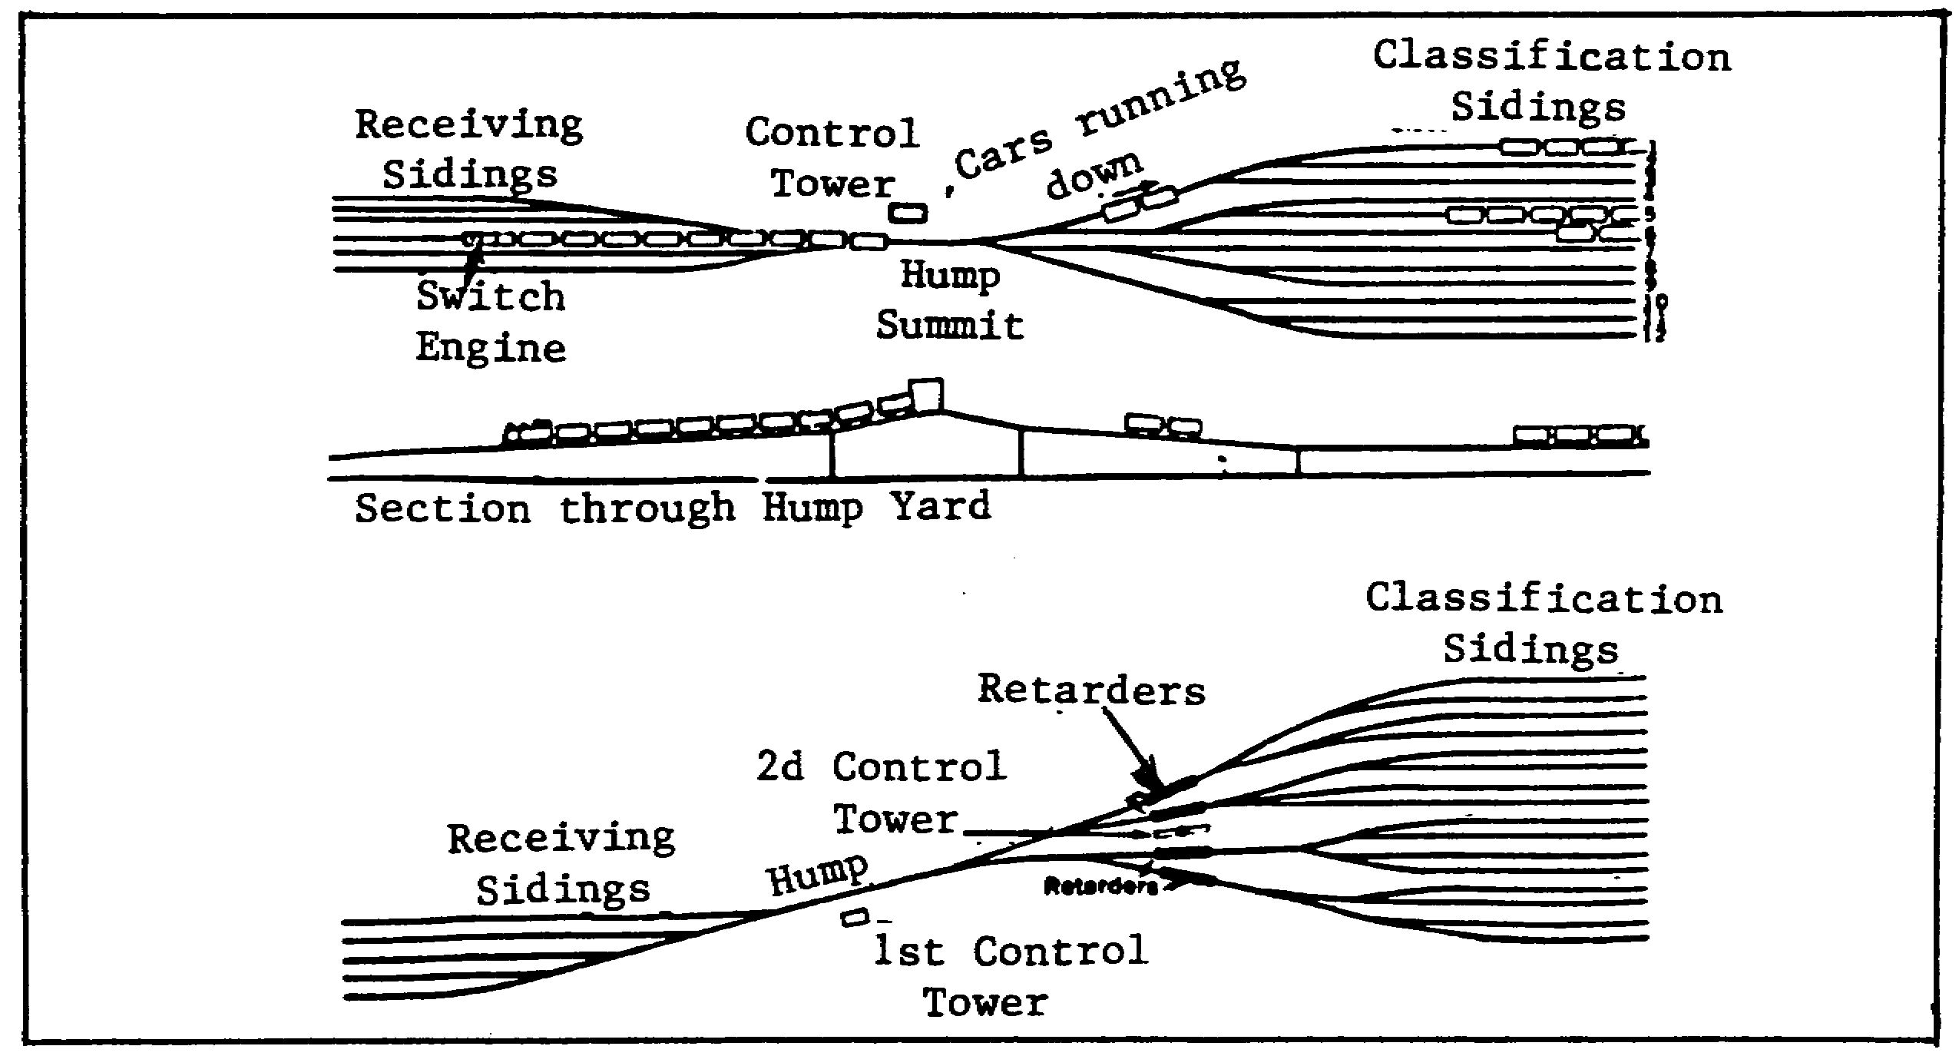

Figure 1-7. Traffic Flow-Gravity or Hump Marshaling Yard.

9 IT0642
NOTE: In some underdeveloped countries, marshaling yards are scarce. Forwarding and receiving yards may be combined into one yard, for example, the upper portion of the yard comprises the forwarding yard and the lower portion the receiving yard. Switch engines will normally not be found in the receiving portion of the yard.

c. Marshaling yard capacity. An approximate estimate of the car capacity of a marshaling yard is important to the IA in making up the report for the commander. Use the following steps (Figure 1-8):

(1) Measure the length of the longest and shortest tracks of the yard. When measuring the longest track, measure it from choke point to choke point. Measure the shortest track from switch to switch located at the end of the shortest track.

(2) Average the track length measurements.

(3) Count the number of tracks across the widest portion of the yard and multiply those times the average track length.

(4) Determine the average car length and divide it into the results of (3) above.

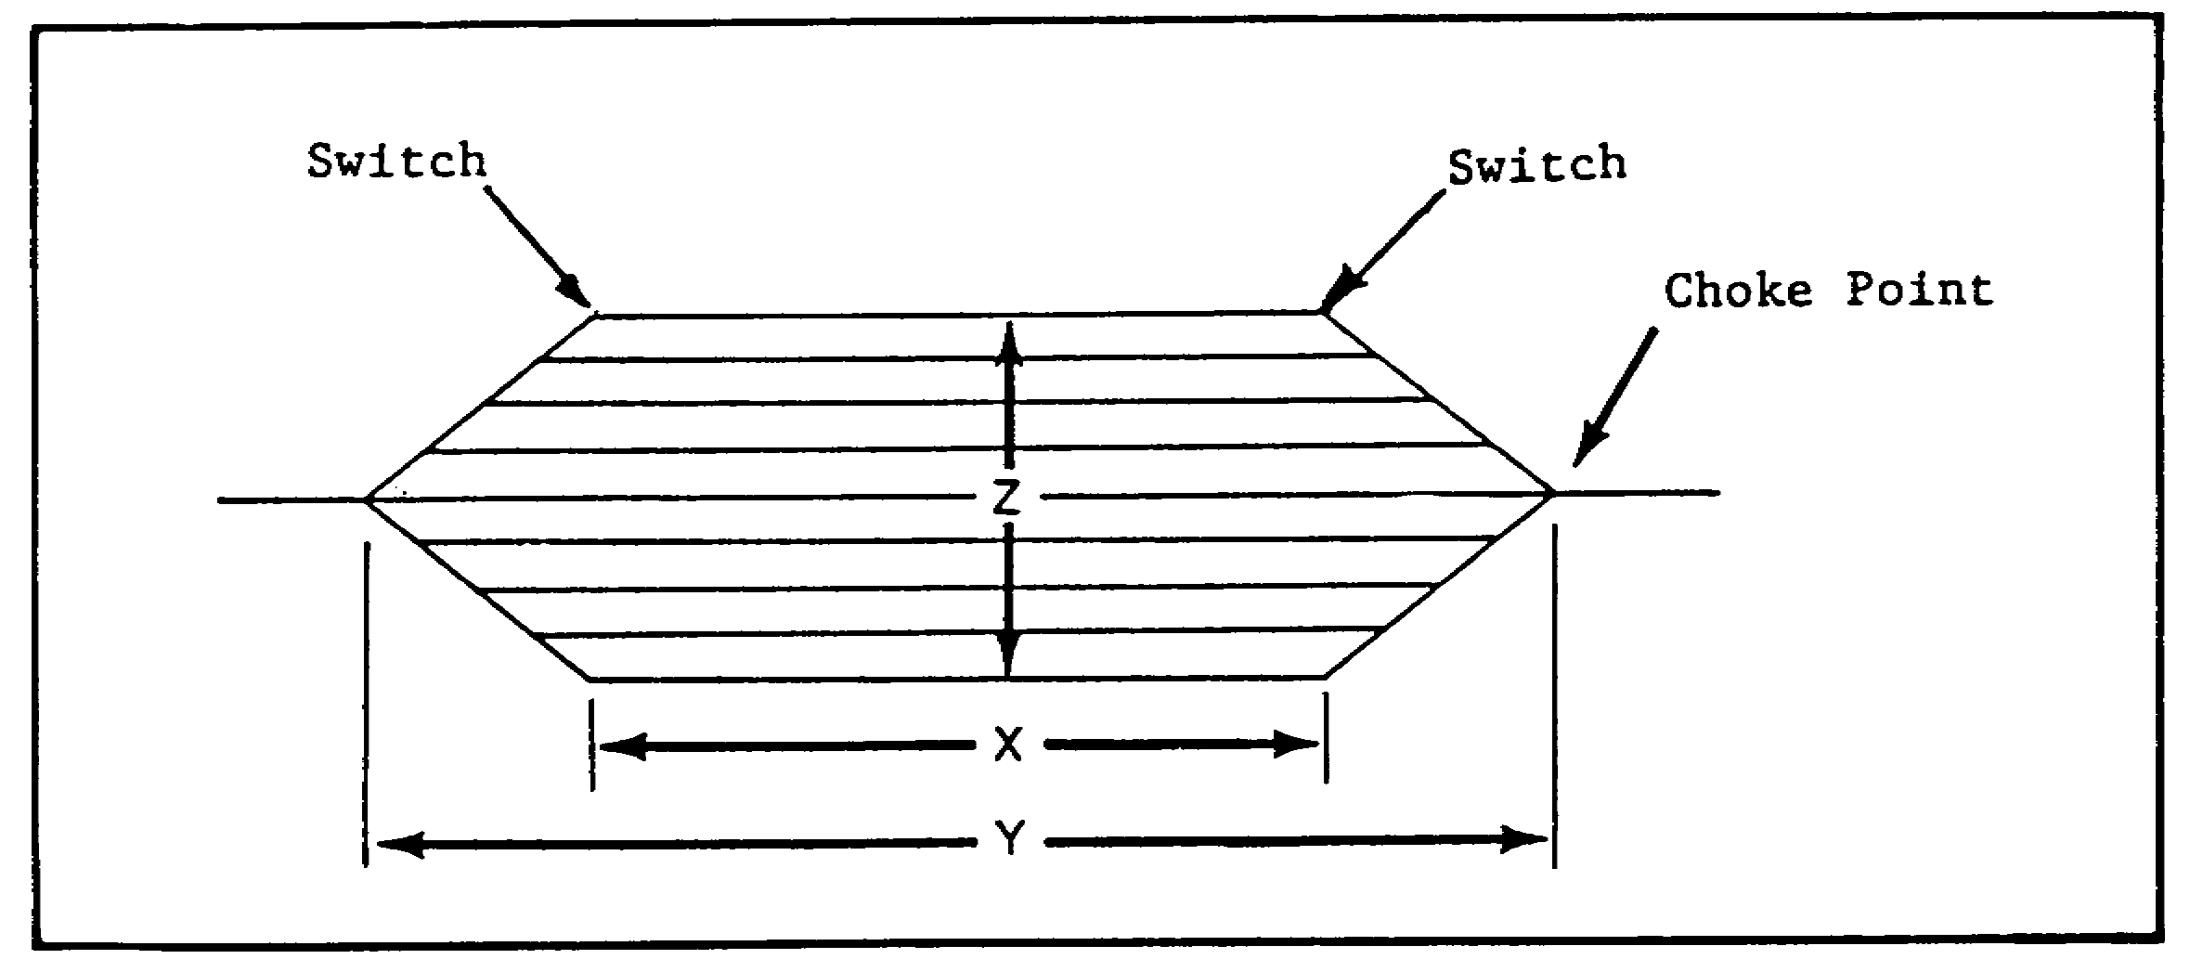

Figure 1-8. Marshaling Yard Capacity.

NOTE: In this illustration 'X' shows the length of the shortest track and 'Y' depicts the length of the longest track. For example: if 'Y' is 2,400ft and "X" is 2,000ft, the average yard length of 2,200ft would be reported. 'Z' depicts the width of the yard that would be reported. The number of tracks reported is simply a count of the tracks at the widest point in the yard. You can see there are nine tracks.

IT0642 10

NOTE: When counting rolling stock/locomotives in the yard, count all those identified between the choke points ('Y' dimension in the illustration).

(5) Use the following formula:

Capacity = Average yard length x number of tracks
Average car length

(6) If the average car length in the yard of the illustration is 40ft, the yard capacity would be 495 cars.

Capacity = 2,200ft x 9 = 19,800 = 495
40ft 40

NOTE: If you cannot visually identify all cars, use your best visual estimate, i.e. 55% x 495 = 272.

5. Holding yards. Holding yards are normally found close to the repair facilities; these are used to hold surplus cars and coaches until they are needed. These yards are normally found only at very large terminals (Figure 1-2).

6. Freight yards. Freight yards are found adjacent to the freight station of a large industry such as a large POL refinery. These yards are used to hold cars until they can be loaded or unloaded. In some instances, the cars may be loaded and/or unloaded directly onto trucks without the use of platforms (Figure 1-2).

PART C: SUPPORT FACILITIES

1. Freight terminals are designed for the temporary storage of goods. Most freight terminals are of the dead end-type; they usually have wide loading areas between tracks.

a. Access from these to nearby streets or roads must be available. The loading areas usually open directly onto adjacent streets. This affords direct access for trucks and other vehicles. The tracks in these areas are known as "team tracks." b. Freight sheds are usually long and narrow and are found at most terminals. Some of these resemble a saw when viewed from above.

c. Other distinctive features of freight terminals are small stacks of freight; end-loading platforms; cold storage warehouses; storage tanks; and special provisions, such as cranes, for handling large or bulky freight (Figure 1-9).

11 IT0642

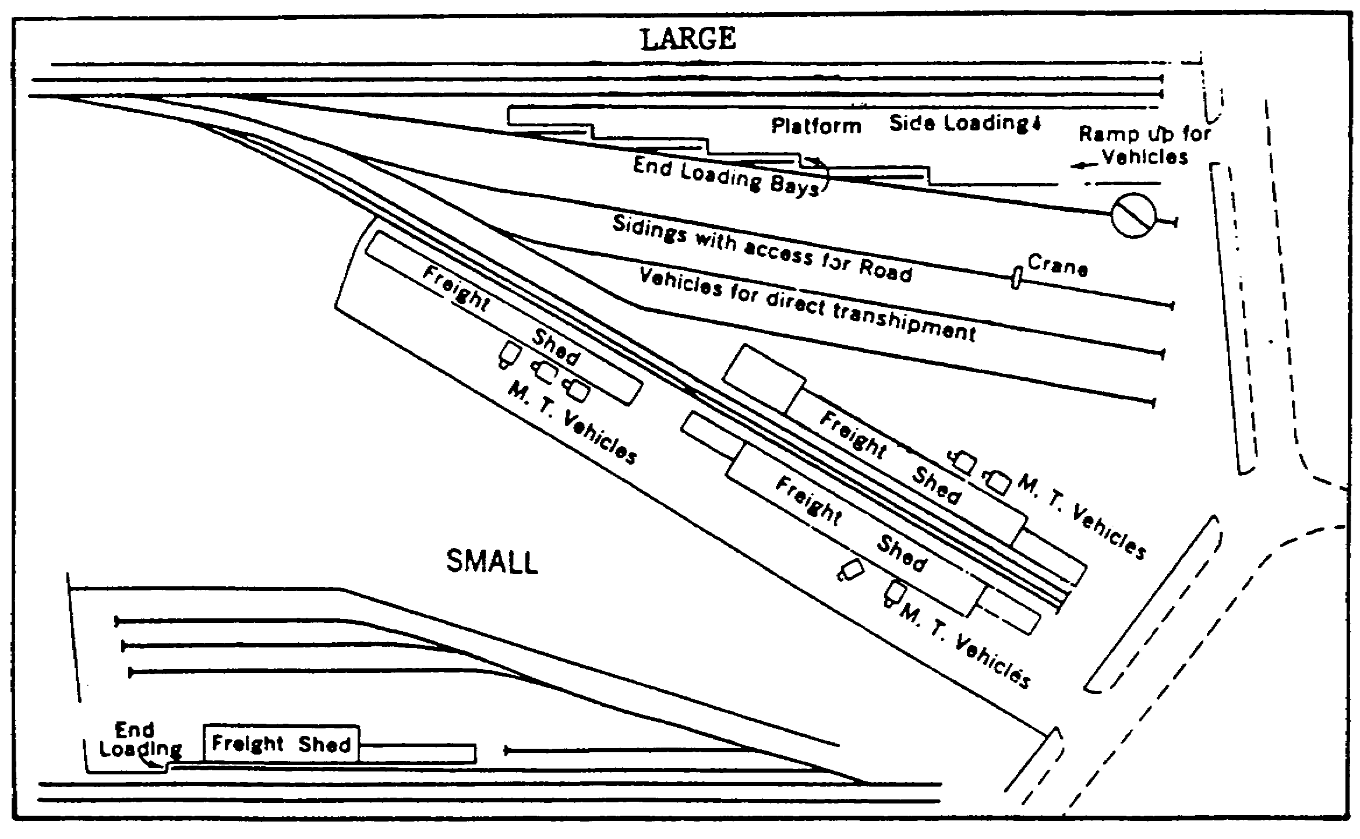

Figure 1-9. Simplified Diagram of a Large and Small Freight Station.

2. Freight transfer and storage areas are where freight is held awaiting transloading from one railcar to another.

a. Freight transfer stations may resemble freight terminals in many respects: loading areas between tracks, freight sheds and stacks of freight are common features. Access to the loading areas from nearby streets, however, is not needed to transload freight from one railcar to another (Figure 1-10).

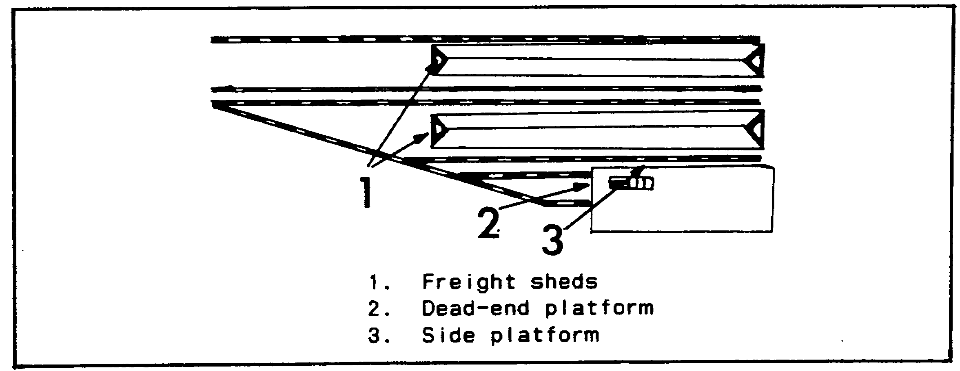

Figure 1-10. Freight Transfer Station.

IT0642 12

b. Open storage areas are not difficult to identify; liquid stores, bulk commodities, or other goods in orderly stacks are generally easy to recognize. Covered stores, with the exception of liquid stores in tanks, are more difficult to identify.

3. Railheads are points where supplies are brought in for further distribution by truck or other vehicles to the using units. A railhead is found to the rear of the fighting troops; it is the end of the rail lines operation. Large amounts of supplies of all types will be found stockpiled at railheads. Any established freight yard could be used by the military as a railhead.

4. Passenger stations.

a. Terminal passenger stations are usually found at the end of a series of tracks. These stations are where passengers arrive or wait for, board and leave on trains. The stations are usually roofed over and consist of large permanent buildings that facilitate the handling of baggage and mail. Passenger movement between platforms in dead-end terminals is by means of an open or covered concourse across the ends of the tracks. The passenger loading platforms frequently project beyond the end of the roof that covers the main part of the terminal (Figure 1-11).

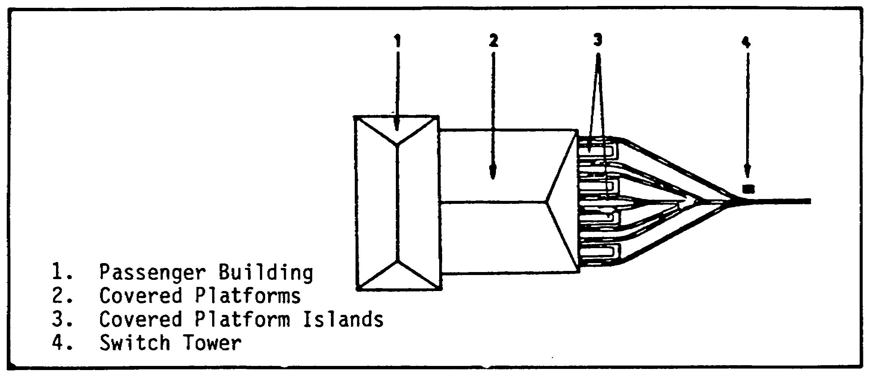

Figure 1-11. Passenger Terminal.

b. A through passenger station is normally covered and usually has a butterfly roof over the platforms so that precipitation drains towards the center. The platforms between the tracks may have an underground access to the terminal (Figure 1-12).

13 IT0642

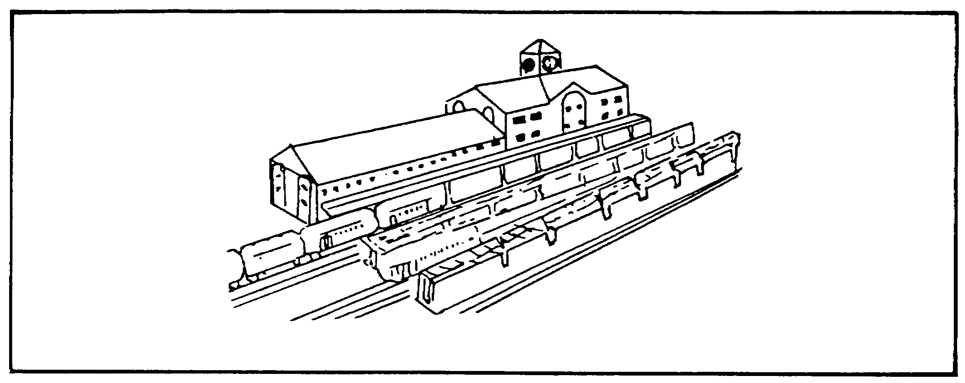

Figure 1-12. Through Passenger Station.

PART D: SERVICE AND REPAIR FACILITIES

1. Service and repair areas are important to any railway system. Since classification and freight yards are terminals for incoming trains, and the centers from which newly formed trains start, they form a very convenient place for service and repair of rolling stock. The repair and servicing installations may vary in size and complexity from a watering tower or coaling station, to a complex grouping of routine servicing during and after each trip, where locomotives and rolling stock are given minor repairs and adjustments as needed. Service and repair for locomotives is generally accomplished in the roundhouses. Adjacent to the roundhouses are other service and repair facilities such as coaling stations, fueling facilities, water and sand towers, and servicing pits (Figure 1-13).

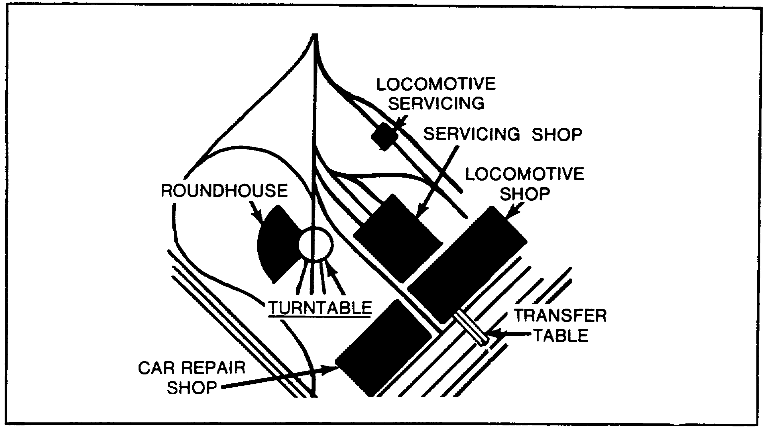

Figure 1-13. Typical Service and Repair Facility.

IT0642 14

2. Roundhouses may be either circular or half circular in shape or in the shape of a rectangle. Turntables are usually associated with a roundhouse and may vary from 15 to 30m in diameter. The number of vents in the roof denotes the capacity of the roundhouse for locomotives. Light repairs and maintenance are carried out on the locomotives in the roundhouse (Figure 1-14).



Figure 1-14. Roundhouse with Turntable.

3. Railcar and locomotive repair shops (Figure 1-15). These repair shops are normally found close to the roundhouse and serviced by dead-end spurs called "shop tracks" or traverser tables. This area may all be in the open or may have buildings large enough to house rolling stock. These buildings are usually long, low rectangularly shaped with tracks running up to them, or they will be serviced by a traverser table. This area is usually for repair of rolling stock other than locomotives. Quantities of supplies should be noted in the area such as piled lumber, sets of wheels, etc. Boiler house or power plant, stores, administration and paint shops may be present.

15 IT0642

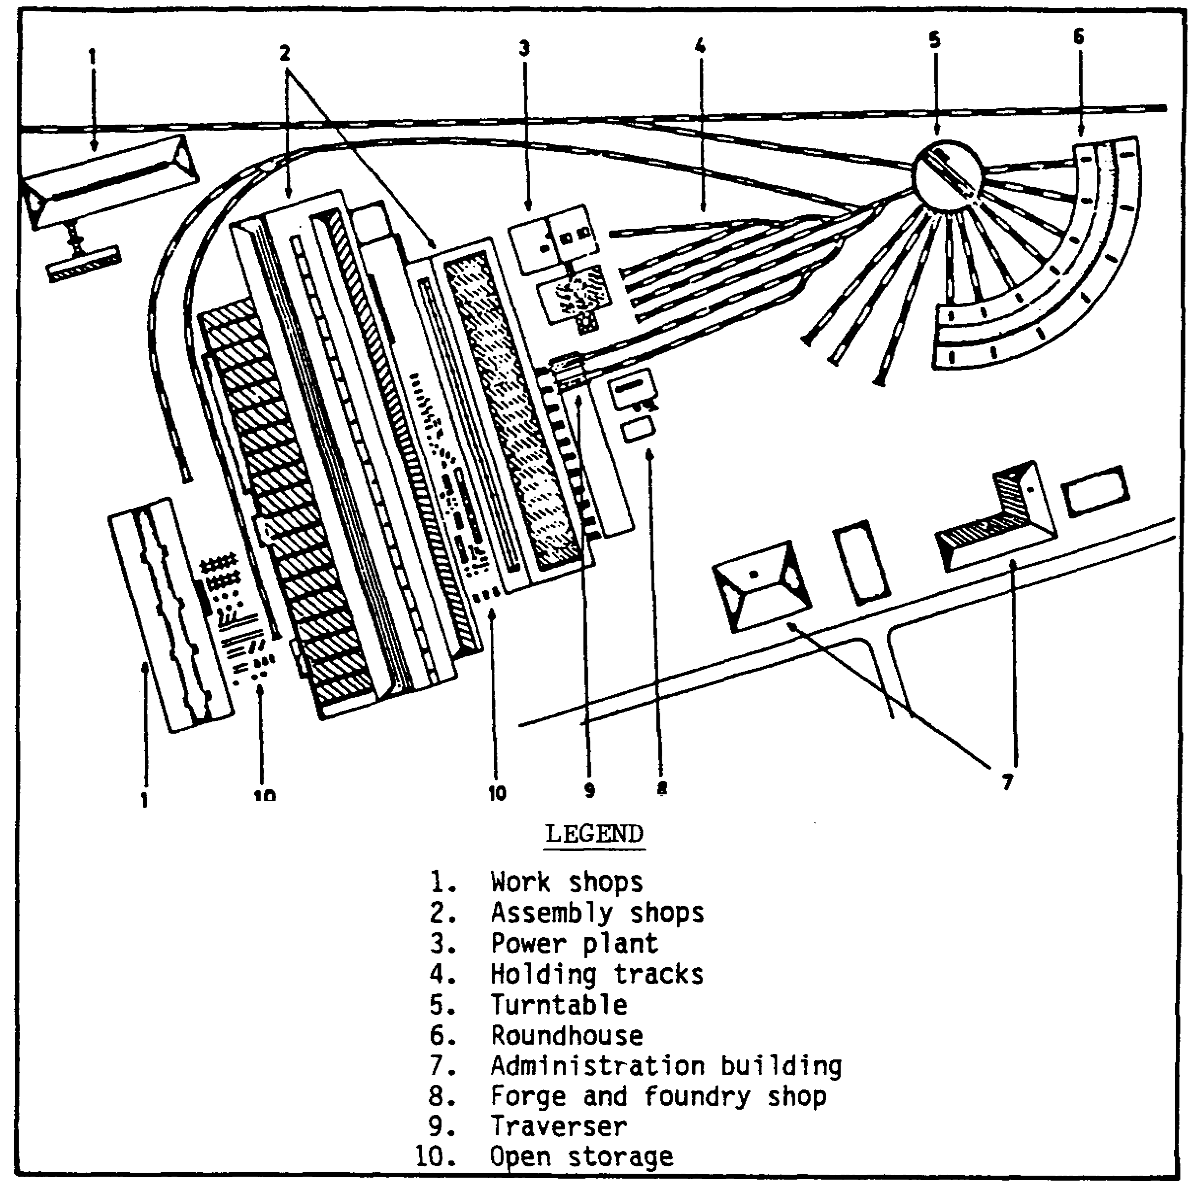

Figure 1-15. Railway Repair Plant.

4. Coalinq points are found where steam engines are used. Two types will normally be found: one, where the coal is stockpiled and loaded into the tender by use of a gantry crane; and two, the coal is stored in a coaling tower and loaded into the tender by use of coal chutes. ;n either case, the surrounding area will be covered with coal dust and the presence of coal cars may be seen (Figures 1-16 and 1-17).

5. Water towers are found where steam .locomotives are used and are located next to the tracks. There are three basic types of water towers. The first is a large water tower with a spout that feeds water into the tenders by gravity. Second is the large standpipe with a spout that feeds water into the tender by a pressure system. Third is the hydrant type, which is used with the water being fed into the locomotive and tender by a large hose (Figure 1-18).

IT0642 16



Figure 1-16. Coaling Point-Crane-Loaded.

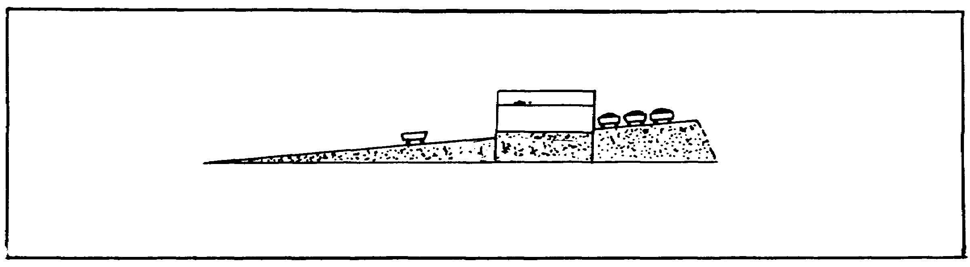

Figure 1-17. Coaling Tower with Coal Chutes.



Figure 1-18. Standpipe with Spout.

6. Switch towers are used to control the right-of-way of railway traffic in rail yards and terminals. They are normally rectangular, two-story buildings situated so they can oversee the rail system. These switch towers operate the signal blocks and the switches along a congested right-of-way and in the railroad yards. The changing of switches is done either manually by the use of levers or automatically through an electrical control board. In large railroad yards, the classification of trains is done automatically by use of humps (Figure 1-19) and automatic switching controlled from the switch tower (Figure 1-20).

17 IT0642



Figure 1-19. Hump.



Figure 1-20. Switch Tower.

PART E: RAIL SYSTEMS

1. Locomotive power. Power for the locomotive, or self-propelled engine, was initially generated by steam. Steam was created by burning wood or coal in the boiler of the locomotive. Nowadays most locomotives are electric or diesel-powered. Steam-powered locomotives are only found in backward countries or as museum pieces.

2. Diesel-powered locomotives and trains basically are using the 2-rail system. Diesel-powered locomotives and trains can also use the 3-rail or even the 4-rail system. However, this is the exception.

3. Electrical rail systems. The term "electrification" is the substitution of electric power for steam or diesel power. Basically, the high voltage current is conducted to the locomotive via rails or overhead cables. The following systems are in use:

* Overhead conductor.

* 3-rail.

* 4-rail.

* Monorail.

* Suspended.

IT0642 18

a. Overhead electric conductor system. Electricity is conducted in cables which are held by poles or by bridge-type supports. This is the most universally used system, the current being carried by cables suspended over the rail track. Spring-loaded "pantographs" (sometimes called "tram poles") on the locomotive pick up the current and return it via the rail line. The IA may not be able to see the overhead cables on the imagery, but the appearance of evenly spaced poles and supports for overhead cables should be discernible (Figure 1-21).



Figure 1-21. Overhead Conductor.

b. 3-rail system. In this system, the conductor is a third rail placed just outside the running track. "Shoes" on the locomotive pick up the current and return it via the running rails (Figure 1-22).



Figure 1-22. 3-Rail System.

c. 4-rail system. In this system, a fourth rail is added and current is returned through it (Figure 1-23).

NOTE: The electric rail systems are unsuitable for countries which have severe winters because of their vulnerability to heavy frost and snow.

19 IT0642

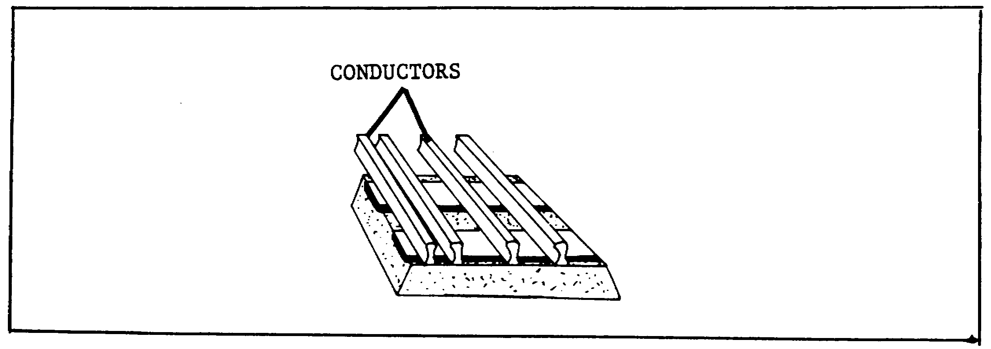

Figure 1-23. 4-Rail System.

d. Monorail (Transrapid) system. In this system, the track is entirely elevated. The equipment for guidance, levitation, and propulsion is fitted to the concrete guideway (Figure 1-24). A transrapid train can reach a speed of 450kmh.

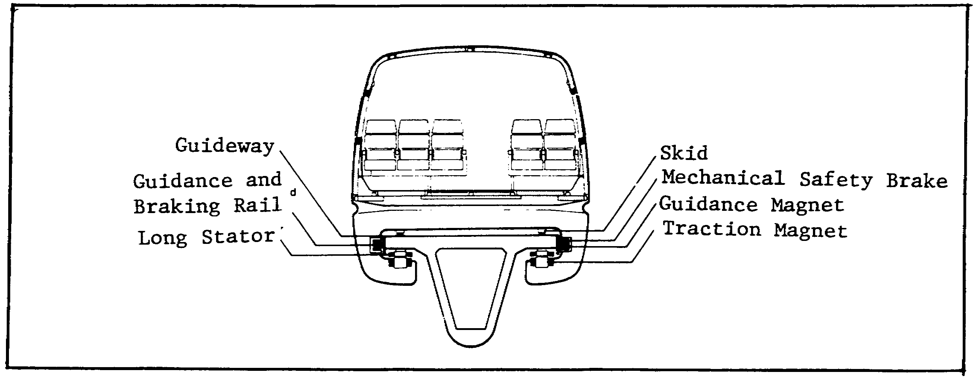

Figure 1-24. Main Components of Transrapid Guidance and Traction System.

Copyright: Jane's World Railways 1989-90, published by Jane's Information Group.

e. Suspended system. In this system, cars are suspended from a boxgirder elevated guideway. The boxes are running within the beam and eight rubber rollers provide lateral guidance. Propulsion is by either two rotary DC motors per bogie or a single linear motor (Figure 1-25).

IT0642 20

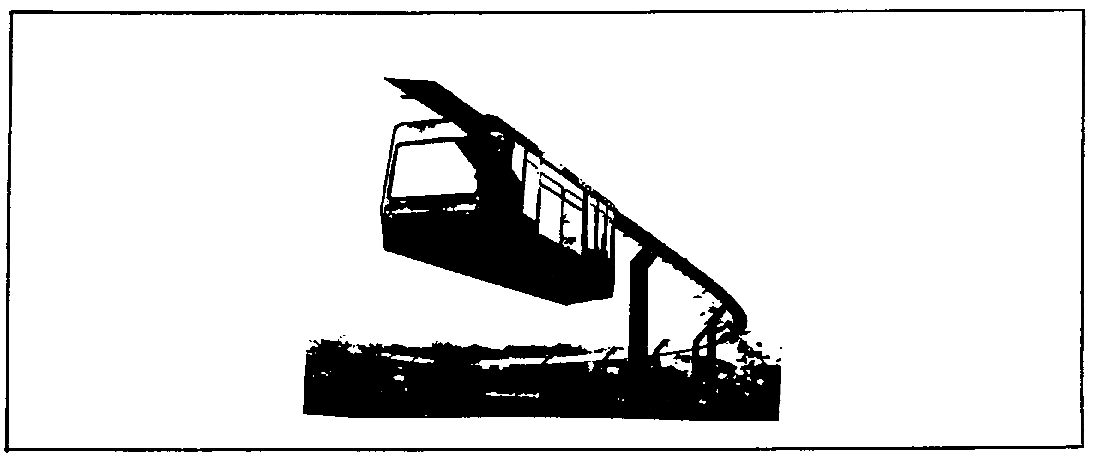

Figure 1-25. Suspended System.

Copyright: Jane's Urban Transport Systems 1988, published by Jane's Information Group.

PART F: ROLLING STOCK AND TRACK DRIVING VEHICLES

1. Rolling stock, such as single vehicles, groups of cars, or entire trains, will be an important clue to the military or industrial activity in a given area. With a few exceptions, rail vehicles of the same vintage have much the same appearance from region to region throughout the world. A diesel-electric locomotive in Moscow will bear a strong resemblance to one in Chicago; a coal hopper in Grodno (USSR) will differ little from one in Pittsburgh. Equipment replacement practices differ considerably, with the result that important regional and national differences in rolling stock can be expected. In China and USSR rolling stock may have been used for 60 years without replacement, but 20-year replacement is common in the highly industrialized western countries

2. Rolling stock and track driving vehicle identification.

a. Any rectangular object appearing somewhat wider than track gauge and several times as long and as wide on railroad tracks may be safely considered a railroad vehicle. Once this assumption has been reached, the IA should, while examining the imagery under study, select one statement from each of the following pairs of statements: The vehicle is covered (it has a roof) or the vehicle is not covered (it has no roof); the vehicle has a smooth, rectangular appearance or the vehicle has a rough, irregular appearance.

21 IT 0642
b. Differences in size, as contrasted with differences in appearance, are common. Vehicles built for wide-gauge tracks are wider than those built for narrow-gauge tracks. The general Asian and Eastern European practice is to use shorter cars than in North America and the USSR.

c. Because of their size, general similarity of appearance, and wide range of dimensions within each class, different classes of railroad vehicles are sometimes difficult to identify or classify. Fortunately, standard passenger or freight trains are relatively easy to detect on aerial imagery of acceptable scale and quality.

d. Once a class has been selected, the selection should be confirmed, if possible, by a study of the descriptive and illustrative material on hand.

3. Locomotives are the most important railroad vehicles since they provide the power for moving all freight and personnel. From a functional standpoint, four types of locomotives are important:

a. Road--mainline and the smaller branch--locomotives are used exclusively for moving trains between yards or terminals.

b. Yard locomotives are used for switching and other local tasks within the yard or terminal itself.

c. Combination locomotives (transit/railcar) have accommodations for passengers and express freight. They are used for short-haul service from a major city to its suburbs.

d. Railcar, trolley, or streetcar locomotives operate as a single unit or they may be pulling one or more coaches.

e. Locomotives may also be classified by their means of propulsion:

o Steam.

o Electric.

o Diesel.

(1) Steam locomotives can frequently be recognized by an uneven appearance caused by cabs, stacks, steam and sand domes, bells, and tenders. There is a trend towards streamlining which is resulting in a smoother, more rounded top and side surfaces; consequently, this would eliminate some important identification features. A small car, called a tender, is identifiable immediately behind steam mainline or switch engines (Figure 1-26).

IT0642 22

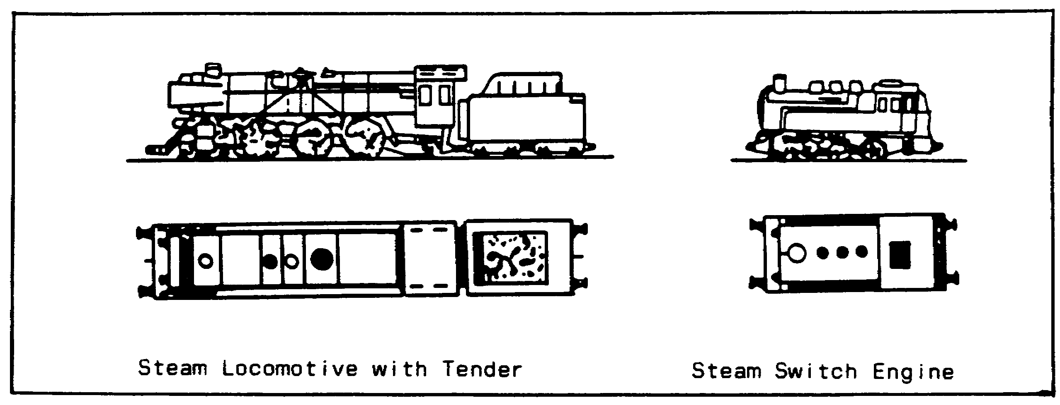

Figure 1-26. Steam Locomotive and Engine.

NOTE: You may identify a steam locomotive equipped with a snow plow used especially in mountainous areas of the temperate zone.

(2) Electric locomotives are not obvious on vertical imagery; some, in fact, are almost indistinguishable from passenger coaches. The pantographs (usually two) are mounted on the roof. They collect electric current from the overhead wire and are sometimes visible on clear or large-scale photography. The overhead gantries or pylons which carry the wires are usually visible (Figure 1-27).

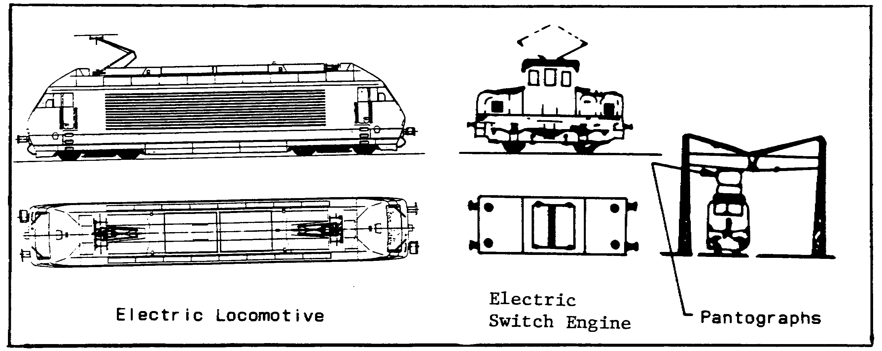

Figure 1-27. Electric Locomotive and Engine.

Copyright: Jane's World Railways 1989-90, published by Jane's Information Group.

(a) Electric locomotive or transit with third rail (Figure 1-28).

23 IT0642

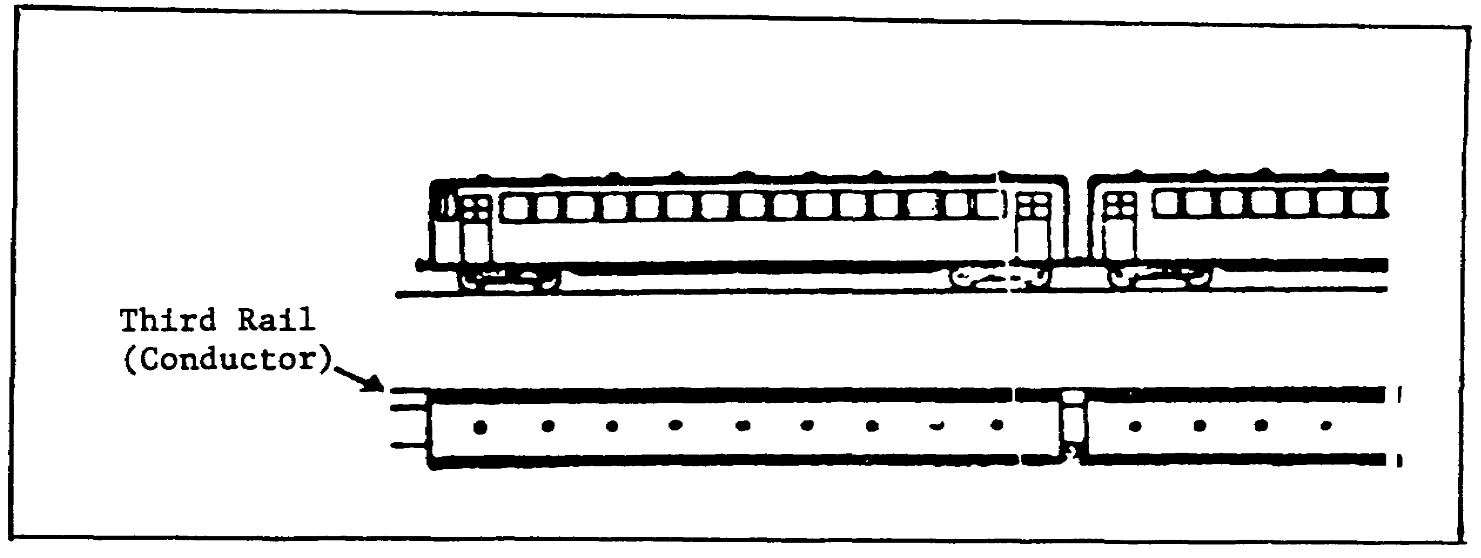

Figure 1-28. Electric Transit with Third Rail.

(b) Electric multiple unit set with catenary (cable extended from two points) or pantograph (Figure 1-29).

(c) Electric-powered passenger vehicles are also used for transportation of passengers (Figure 1-29).

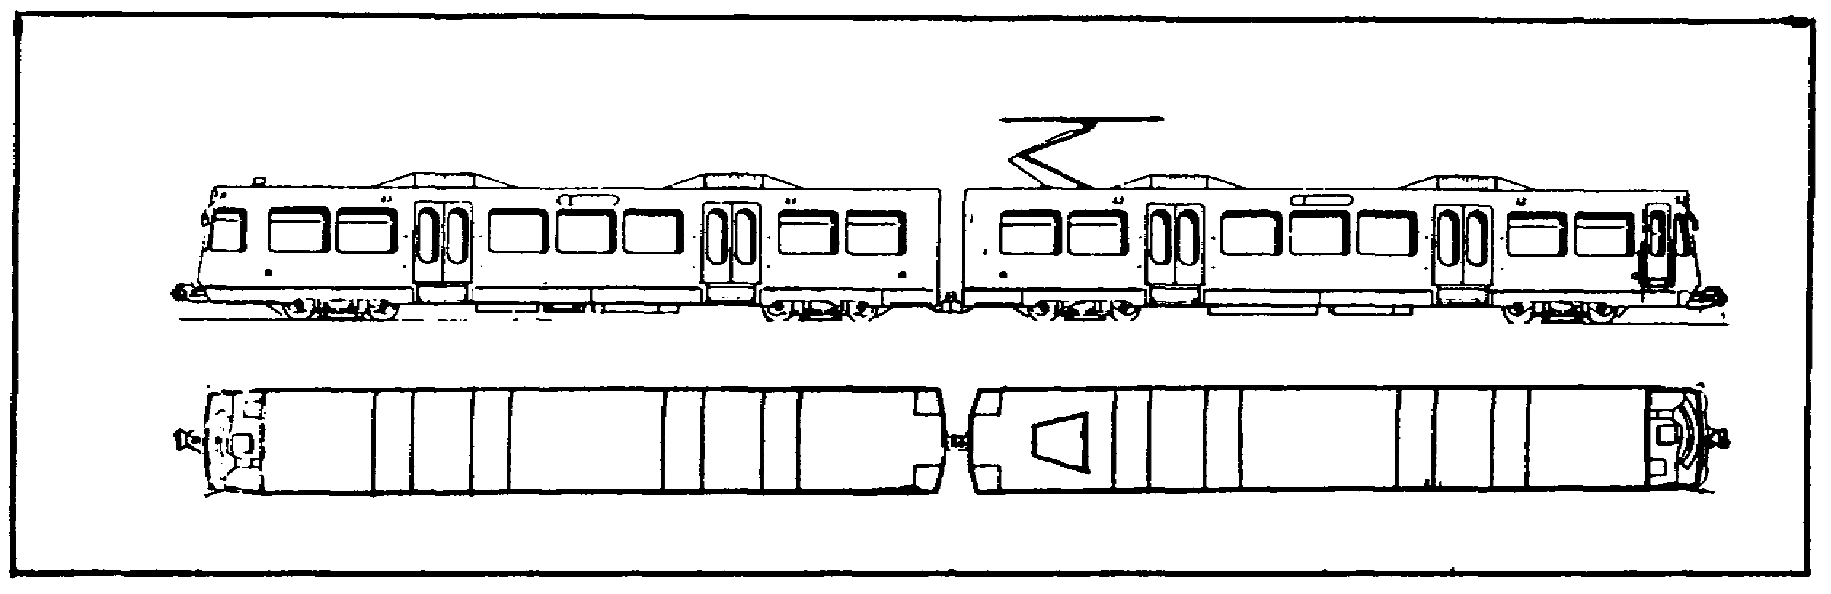

Figure 1-29. Electric-Powered Vehicle with Pantograph.

Copyright: Jane's World Railways 1989-90, published by Jane's Information Group.

(3) Diesel locomotives are identified by their streamlined appearance. Lengths vary from switch engines 24 to 30ft long to the mainline passenger and freight engines of 35 to 50ft in length (Figure 1-30). Locomotives longer than 50ft are used for special purposes, such as crossing steep, mountainous terrain.

IT0642 24

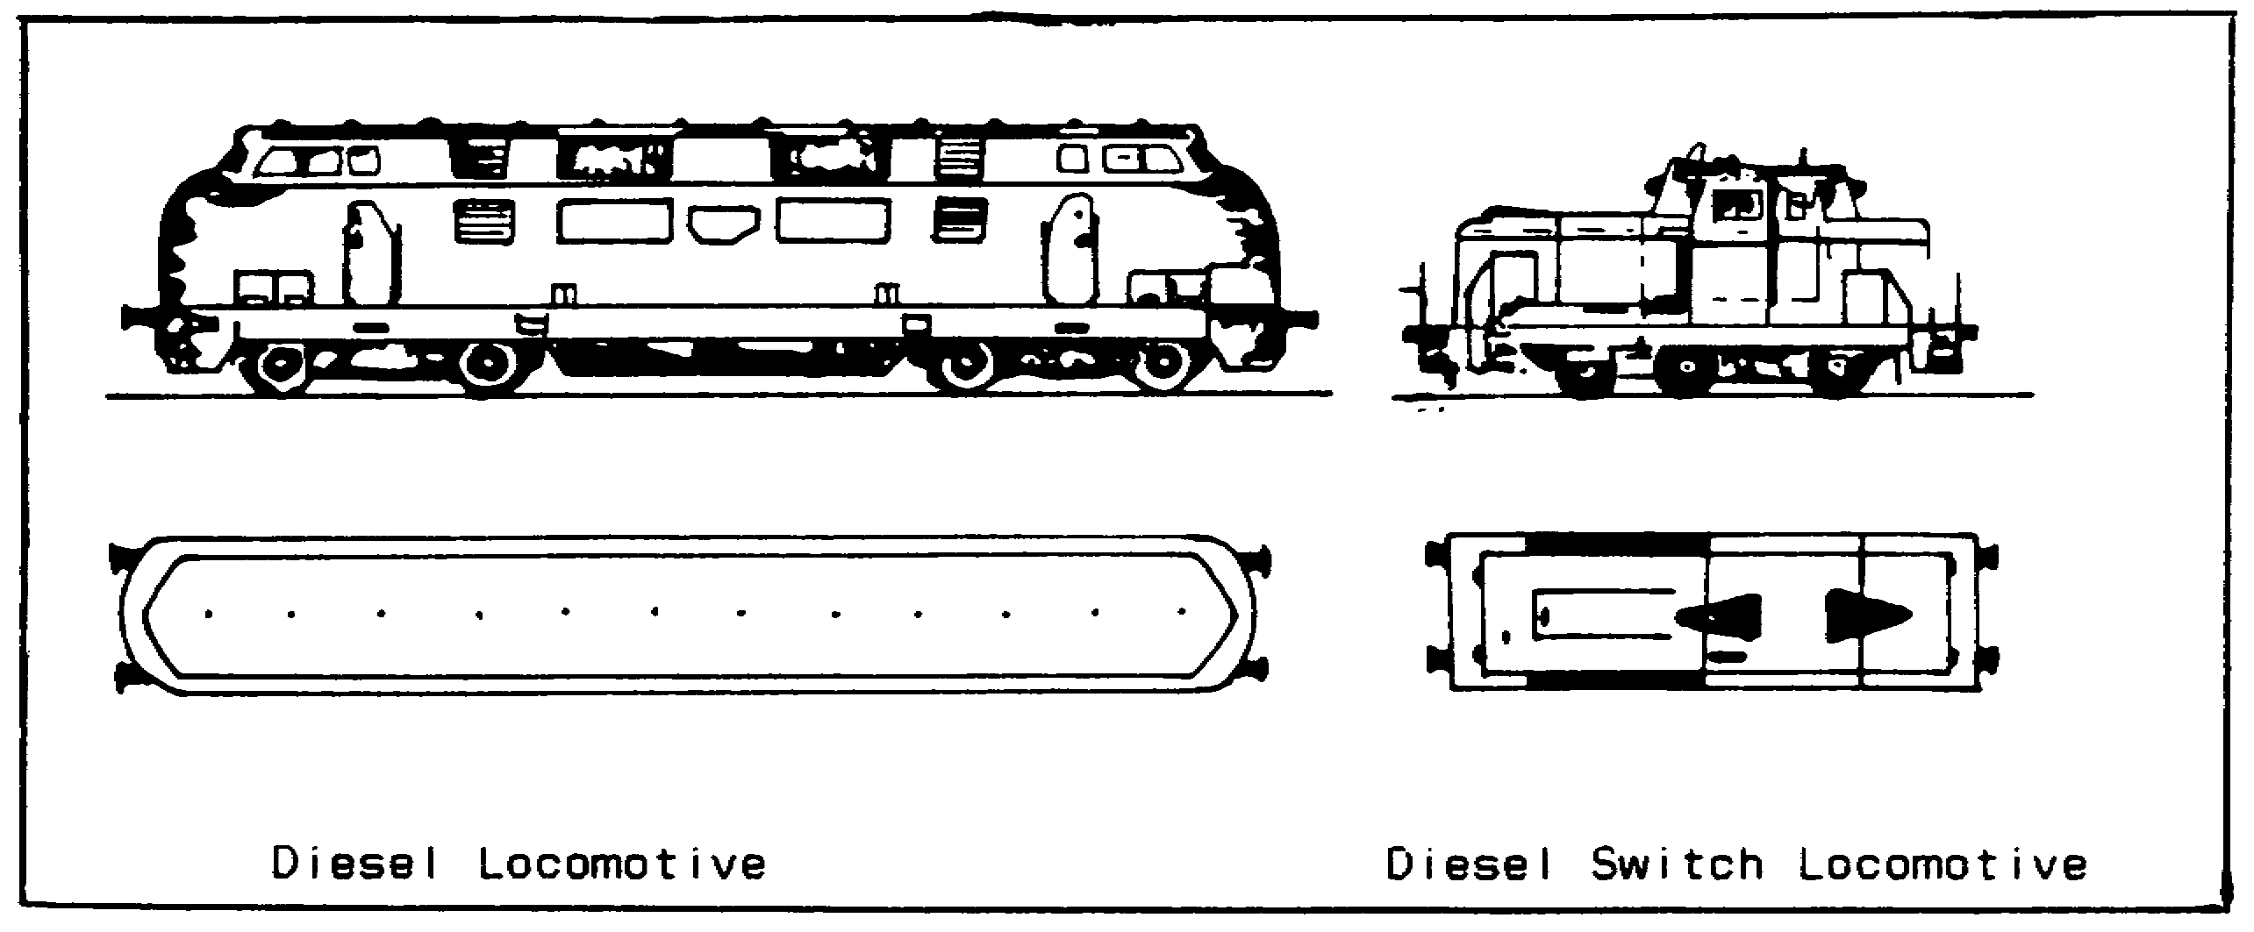

Figure 1-30. Diesel Locomotives.

4. Passenger cars. There are many functional types of passenger cars, such as coaches, sleepers, diners, conference or club cars, and baggage cars (Figures 1-31 thru 1-36).

a. Coaches can be classified as long distance or local. The long distance passenger coaches are usually very long (65 to 75ft) with the ends usually rounded. This type of coach is further divided into several types: express, dining, sleeping, conference or club, and baggage.

b. Local coaches are much smaller, about 40ft or less, and are sometimes confused with freight cars. The ends of these coaches are usually square, and they are coupled closer together with a covered platform between cars that will give the impression of one continuous line.

NOTE: When long-distance or local cars are used for hospital trains, the Geneva Convention requires each roof have a red cross painted on a field of white; prisoner-of-war trains are required to have the large, white letters POW on the roof tops.

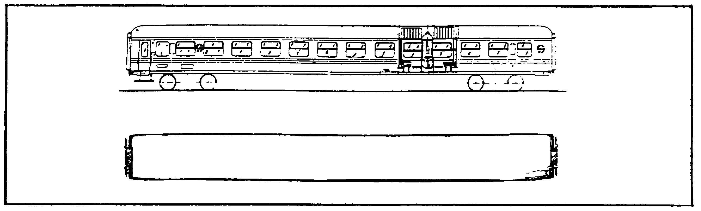

Figure 1-31. Passenger Coach.

Copyright: Jane's World Railways 1989-90, published by Jane's Information Group.

25 IT0642

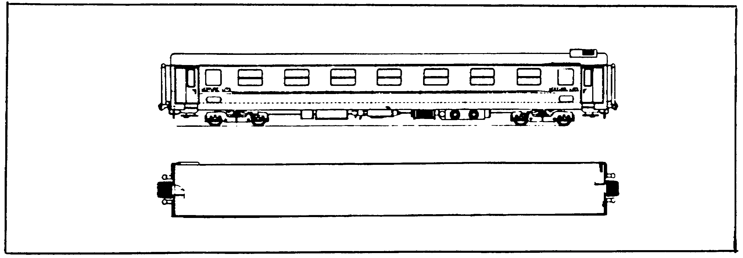

Figure 1-32. Sleeping Car.

Copyright.: Jane's World Railways 1989-90, published by Jane's Information Group.

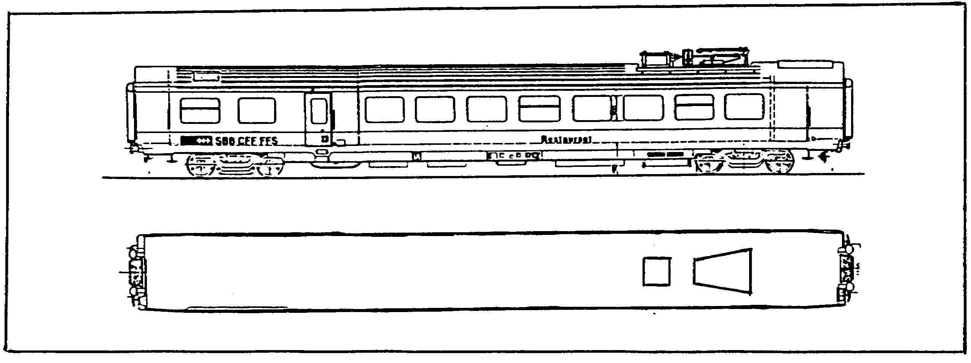

Figure 1-33. Restaurant Car.

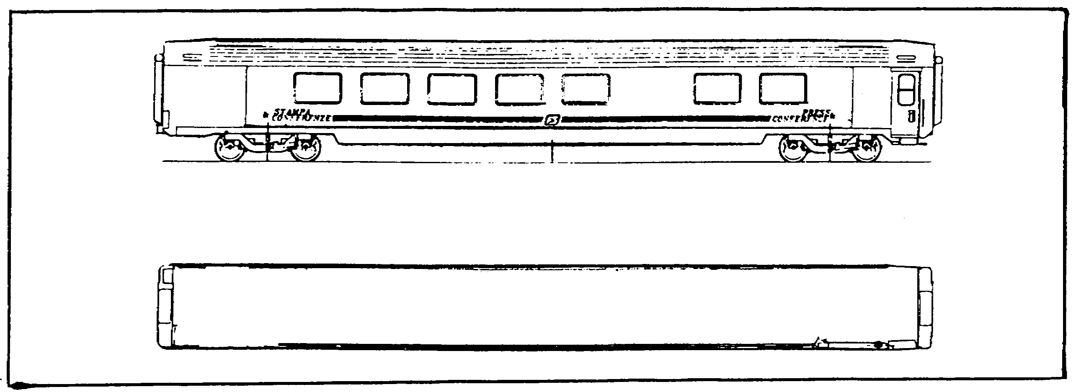

Figure 1-34. Conference Car.

Copyright: Jane's World Railways 1989-90, published by Jane's Information Group.

IT0642 2-26

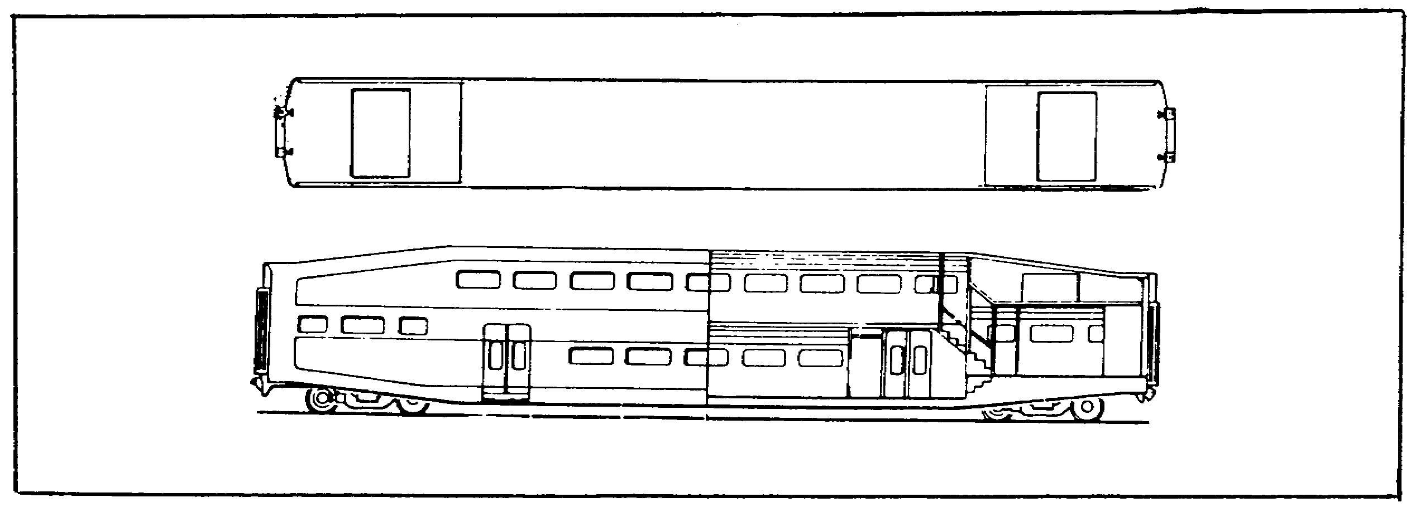

Figure 1-35. Bi-level Car.

Copyright: Jane's World Railways 1989-90, published by Jane's Information Group.

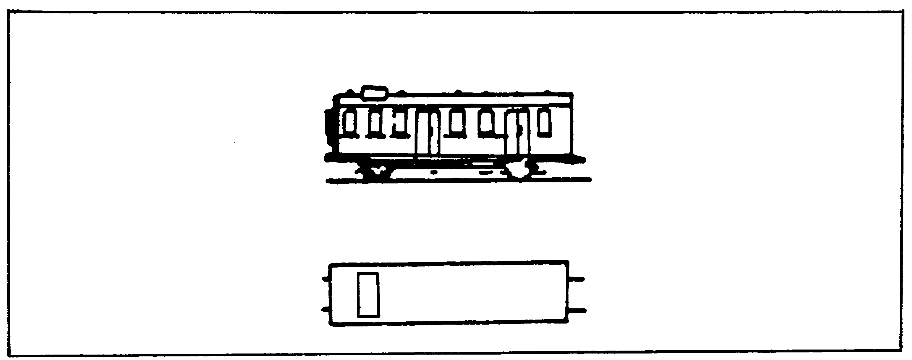

Figure 1-36. Baggage Car.

5. Freight cars are the most numerous type in use today. There are two major types of freight cars, covered and open. Covered cars include boxcars, cattle cars, refrigeration cars and tank cars. Uncovered cars include hopper cars, regular and well-type flat cars, and gondola cars with high, medium or low sides.

a. Boxcars have a flat or slightly rounded top and are square-ended, covered cars. Some have catwalks on top. Sizes vary from 27 to 50ft in length (Figure 1-37).

27 IT0642

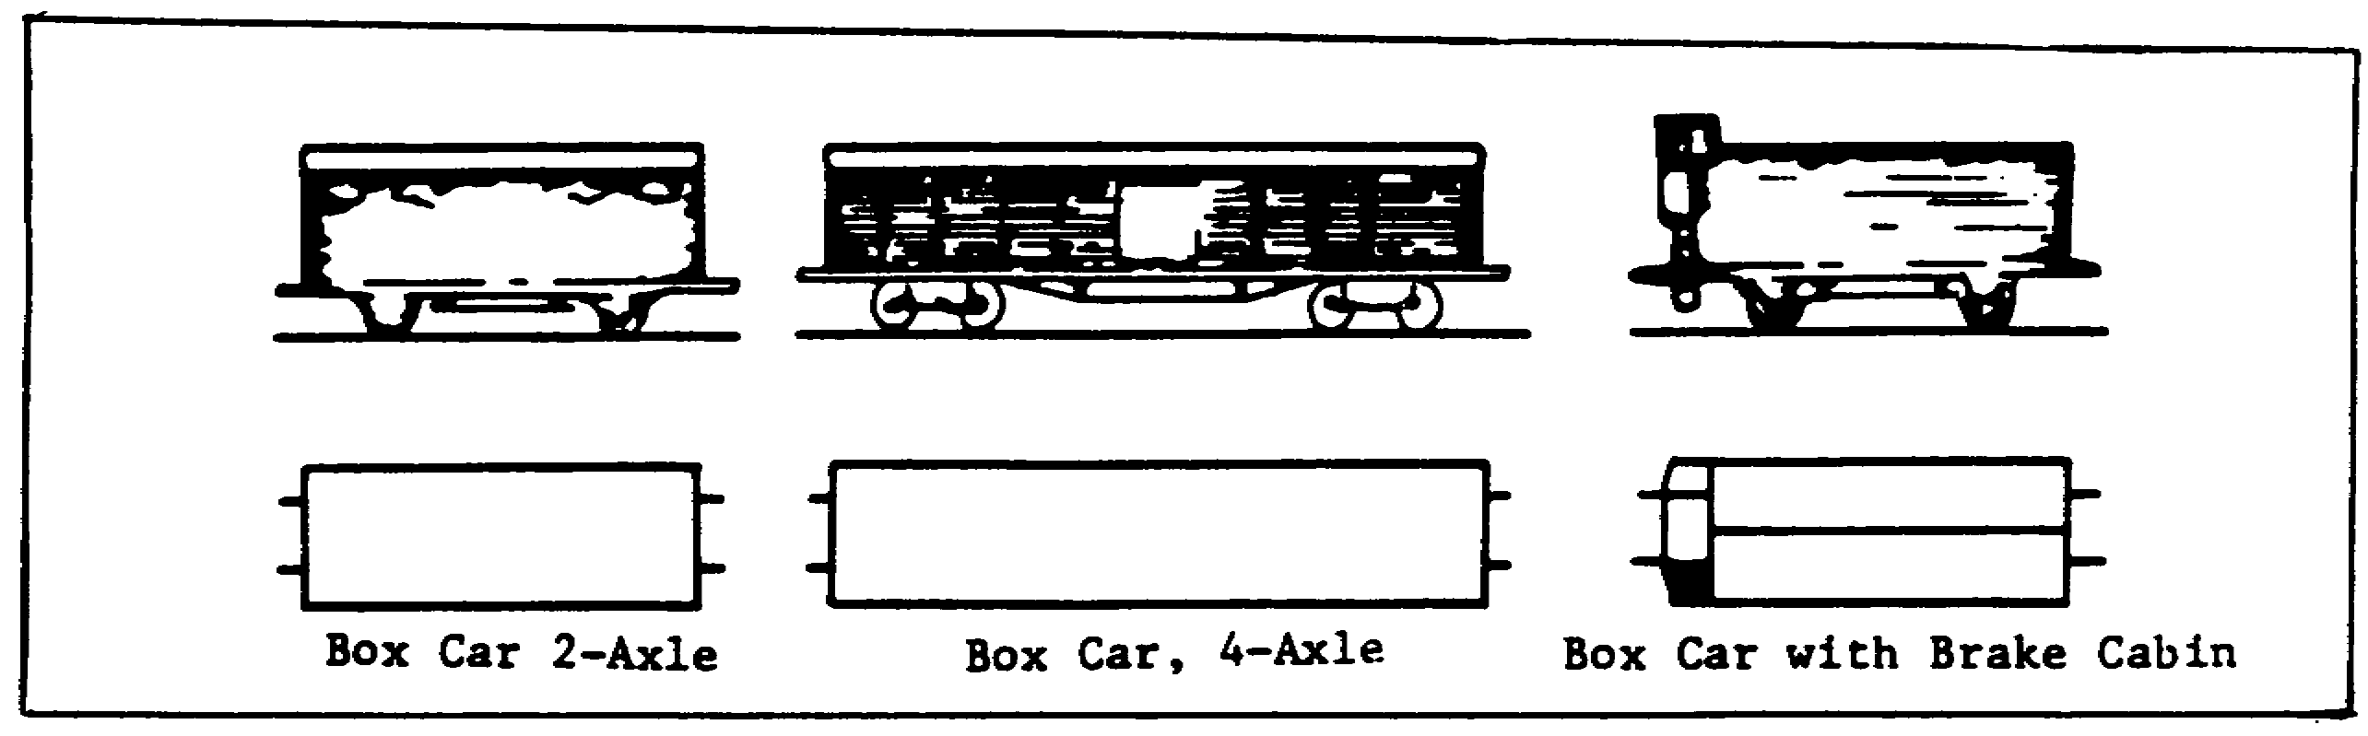

Figure 1-37. Boxcars.

b. Gondola cars are open, flat-bottom cars with low or high siding around them. The siding may be as high as 4 to 5ft. Lengths vary from 22 to 50ft (Figure 1-38).

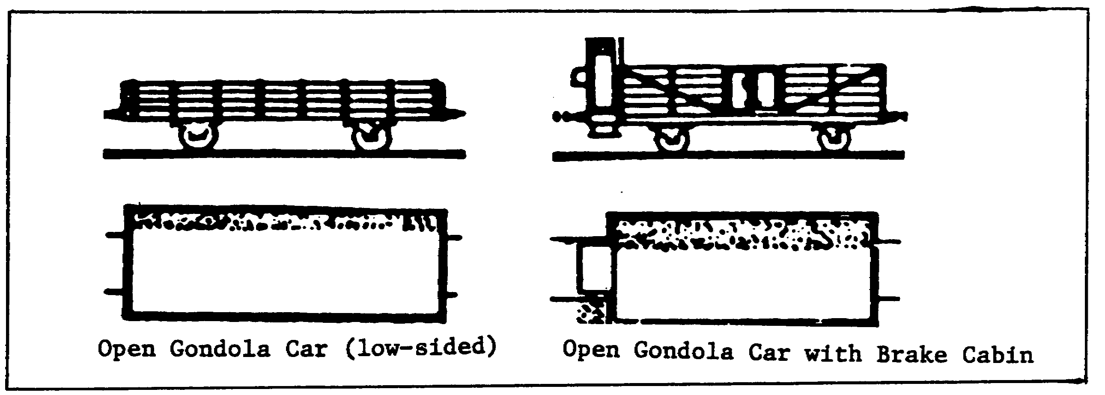

Figure 1-38. Gondola Cars.

c. Hopper cars are open-top, high-sided cars with sloping bottoms. There are doors at the bottom or side for discharging the contents of the car (Figure 1-39).

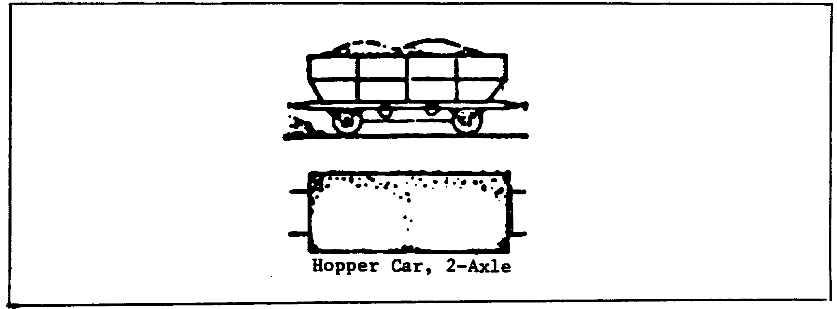

Figure 1-39. Hopper Cars.

IT0642 28

d. Tank cars are easily recognized by their characteristic round tank, mounted horizontally on wheels or with two or three round tanks mounted sideways on a flatcar. These are used for POL, chemicals or water (Figure 1-40).

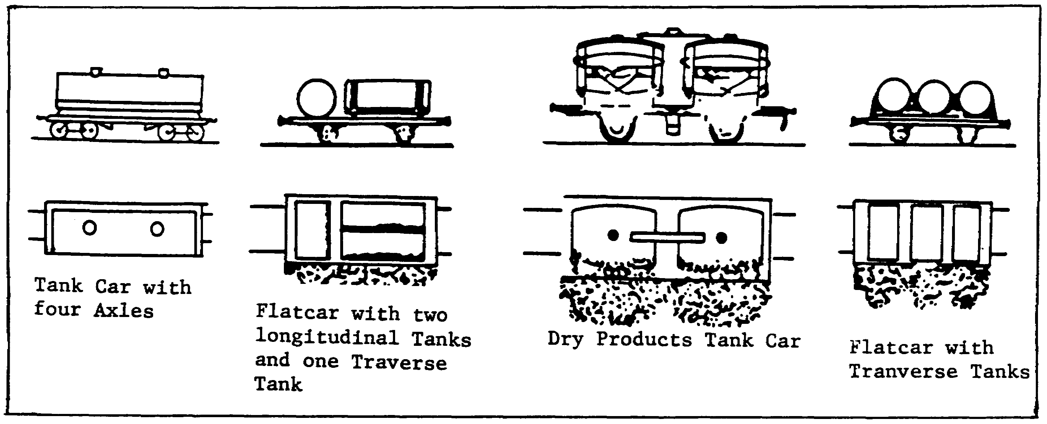

Figure 1-40. Tank Cars.

e. Flatcars are used for transporting heavy or large equipment. They may have bolsters (clamp fasteners for cables or chains) or stanchions (upright braces) on them. Well cars are similar to flatcars except the bed between the wheels is lowered to handle heavy or large loads (Figure 1-41).

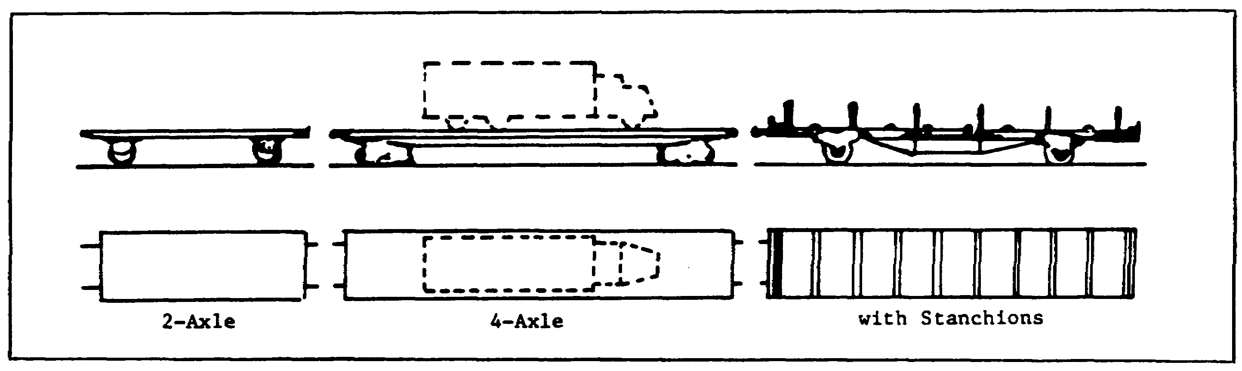

Figure 1-41. Flatcars.

f. Mobile cranes used in bridging, maintenance, derailments, and accidents. In transit, the lowered jib is carried on "match-truck" (small flatcar)(Figure 1-42).

29 IT0642

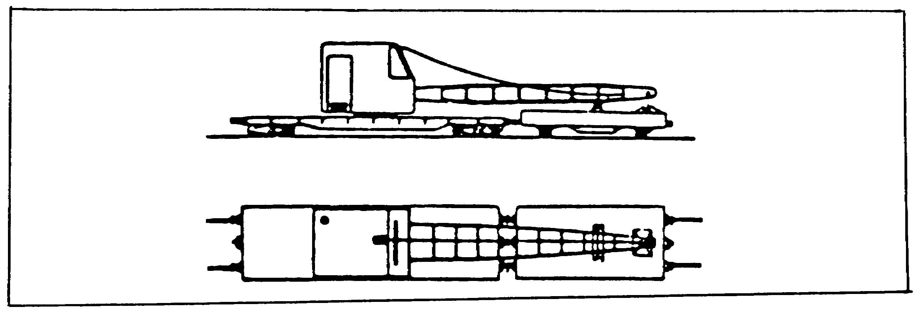

Figure 1-42. Flat Car with Crane.

g. Other types. More rolling stock is being developed toward a specific purpose or load, such as the large boxcar or the open three-decker automobile types. Ore cars are another type 'of car made for one specific load. They are often found on narrow gauge track as well as standard gauge track. Special flat cars have been developed for hauling missiles (Figure 1-43).

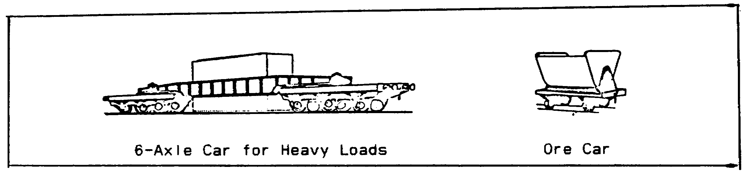

Figure 1-43. 6-Axle Car and Ore Car.

6. Special purpose rolling stock. There are numerous special purpose vehicles associated with railroads which are likely to confuse an IA when first encountering them on aerial imagery. The number of vehicles designed specifically to be used in construction and maintenance is Increasing, especially in the more industrialized areas of the world.

a. Some of the different types an IA may come across are snowplows, track layers, ballast spreaders, vegetation removers, and inspection cars. In addition to track layers, the USSR uses electropneumatic spike hammers and electric spike pullers. Ditchers, scrapers, and graders are other types of Soviet on-rail equipment. Off-rail equipment includes cranes, stationary conveyors, pile drivers, bridge jacks, and pneumatic tampers.

b. When vehicles are modified for strictly military purposes, major alterations are often necessary. These alternations create new vehicle classes for lAs to recognize. There are several types of special purpose military vehicles. Most of them are designed to provide offensive, defensive, or special transportation support. Special flatcars have been
developed for hauling of large loads that are long and heavy, especially
for the transport of missiles or railroad guns.

IT0642 30

7. Freight trains carrying military unit equipment almost always make extensive use of flat, gondola, or special-purpose cars for larger equipment. Special flatcars have been developed for hauling missiles.

a. Recognition of a variety of such equipment (trucks, jeeps, tanks, guns, and so on) on a single train strongly suggests unit movement. The types and quantities of equipment observed will, or course, be clues to the nature and size of the unit being moved.

b. Mixed trains are easy to recognize. They have the length of freight trains, but include a sizable number of passenger cars. This combination is seldom used except for military purposes.

c. Large railway guns (up to 380mm) mounted on flatcars may be used either against ground fortifications or as coastal defense guns.

d. Rail-mounted heavy, medium, or light antiaircraft weapons were used extensively by the Germans in World War II to defend important targets from air attacks. Similar weapons appeared in Korea and North Vietnam. Fully armored trains with armored locomotives have received wider use in the USSR than in any other country. They are currently used by military police troops.

e. The transportation of military units by rail can be accomplished either by the use of separate passenger and freight trains, or by the use of mixed trains with both passenger and freight cars. From the IA's viewpoint, little, if anything, distinguishes a troop-carrying passenger train from other passenger trains.

f. Determination of the type of unit being transported, however, is considerably more difficult, because it is based more on order of battle information and the type of equipment being moved rather than on the characteristics of the train.

PART G: RAILROAD VULNERABILITIES

1. Rail facilities are used extensively in the rear area in support of the battlefield. As the front lines move forward, the railhead also advances as fast as possible in an effort to alleviate transportation problems. It will be your job to identify the railheads, types of material, and number of personnel being off-loaded. You must be able to identify crucial points in the enemy's lines of communication so they can be neutralized.

2. Railways and their associated facilities are highly vulnerable to enemy attack, particularly to sabotage and guerrilla operations. Since the routes are relatively straight and limited to certain types of terrain, camouflage and protection are extremely difficult and, in many cases, impossible. The requirement for large, open facilities located in broad, flat areas adds to the difficulty in protection. Keeping a railroad in operation requires trained security forces and extensive protective measures.

31 IT0642

3. Rail lines and their facilities are particularly vulnerable to interdiction. The destruction of one or more choke points or switch towers can tie up an entire rail network for days. Destruction of key tunnels or bridges can tie up a rail network for weeks. Success in any interdiction, however, depends on your ability to recognize and identify key rail facilities as lucrative targets. Obviously, railroad identification is a valuable skill in any IA's background.

4. Deception attempts could be created by putting decoy or unused rolling stock at a vacant rail facility. Railheads may be supplemented by camouflage, air defense facilities and other defensive measures. Supplies are often unloaded from railway cars onto trucks and carried to a storage point. Since this is standard practice a decoy breakdown point may be used. The decoy point may be more exposed and obvious than the real one.

IT0642 32

LESSON

PRACTICE EXERCISE

The following items will test your grasp of the material covered in this lesson. There is only one correct answer for each item. When you have completed the exercise, check your answers with the answer key that follows. If you answer any item incorrectly, study again that part of the lesson which contains the portion involved.

1. Which conditions are unsuitable in the use of electrified systems in some countries?

A. Electric power production limitations.

B. Severe winters.

C. Wind.

D. Rain.

2. Which type locomotive is normally used for short haul service?

A. Mainline.

B. Yard.

C. Combination transit/railcar.

D. Streetcar.

3. What is the standard gauge measurement of a railway in the US and Europe?

A. 3.81m.

B. 3.81ft.

C. 4.71m.

D. 4.71ft.

33 IT0642

4. Railcars moving from the classification yard to the forwarding yard usually pass through a:

A. Choke point.

B. Passenger station.

C. Receiving yard.

D. Turntable.

5. A marshaling yard that uses the gravity system can be identified by what key identification feature?

A. Receiving yard.

B. Forwarding yard.

C. Classification yard.

D. Retarders.

6. What is the overall capacity of a marshaling yard with the following data? Average yard length = 1,500ft, average length of the rolling stock = 50ft, and number of tracks = 22.

A. 550.

B. 660.

C. 2,000.

D. 3,490.

Refer to photo 642-01 for questions 7 and 8.

7. What feature is at Annotation A?

A. Hopper car.

B. Tender.

C. Flatcar.

D. Conference car.

IT0642 34

8. Which railcar is at Annotation B?

A. Dining car.

B. Flatcar.

C. Covered boxcar.

D. Open boxcar.

35 IT0642

LESSON

PRACTICE EXERCISE

ANSWER KEY AND FEEDBACK

Item Correct Answer and Feedback

1. B. The electric rail system is unsuitable for countries with severe winters
(page 19, note).

2. C. Combination transit/railcars are used for short haul service
(page 22, para 3c).

3. D. 4.71ft is the standard gauge measurement of a railway in the US and Europe (page 5, para 3a(1)).

4. A. A choke point is normally at the entrance of a forwarding yard
(page 8, para 3b).

5. D. Retarders are used in the receiving yard in the gravity system of a marshaling yard (page 9, para 4b).

6. B. The average capacity for this yard is 660. Using the formula

Capacity = Average yard length (1,500ft) x number of tracks (22)
Average car length (50ft)

(pages 10/11, para 4c).

7. A. This is a hopper car (apparently empty)(page 28, para 5c/fig 1-39).

8. C. This is a roof covered boxcar. The door is open, ready to discharge or load freight (page 27, para 5/fig 1-37).

IT0642 36

